**本文档主要是对Panel下的Items中的内容进行测试**

* 打开Panel测试

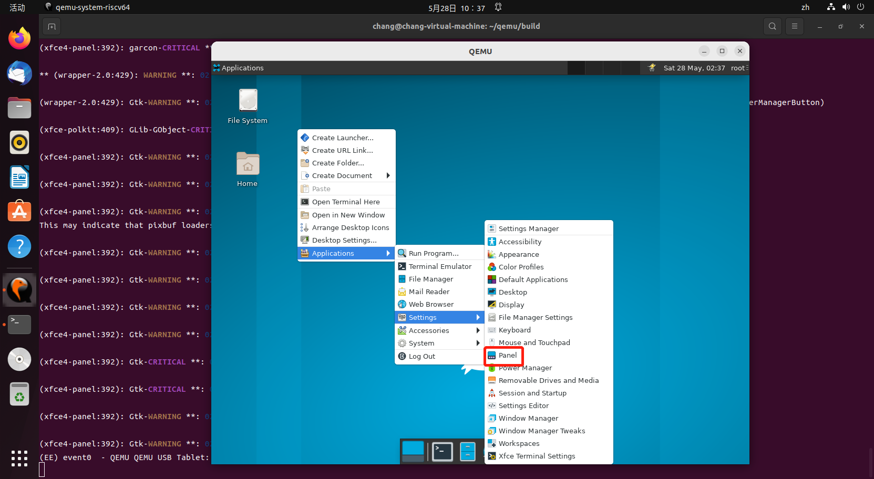

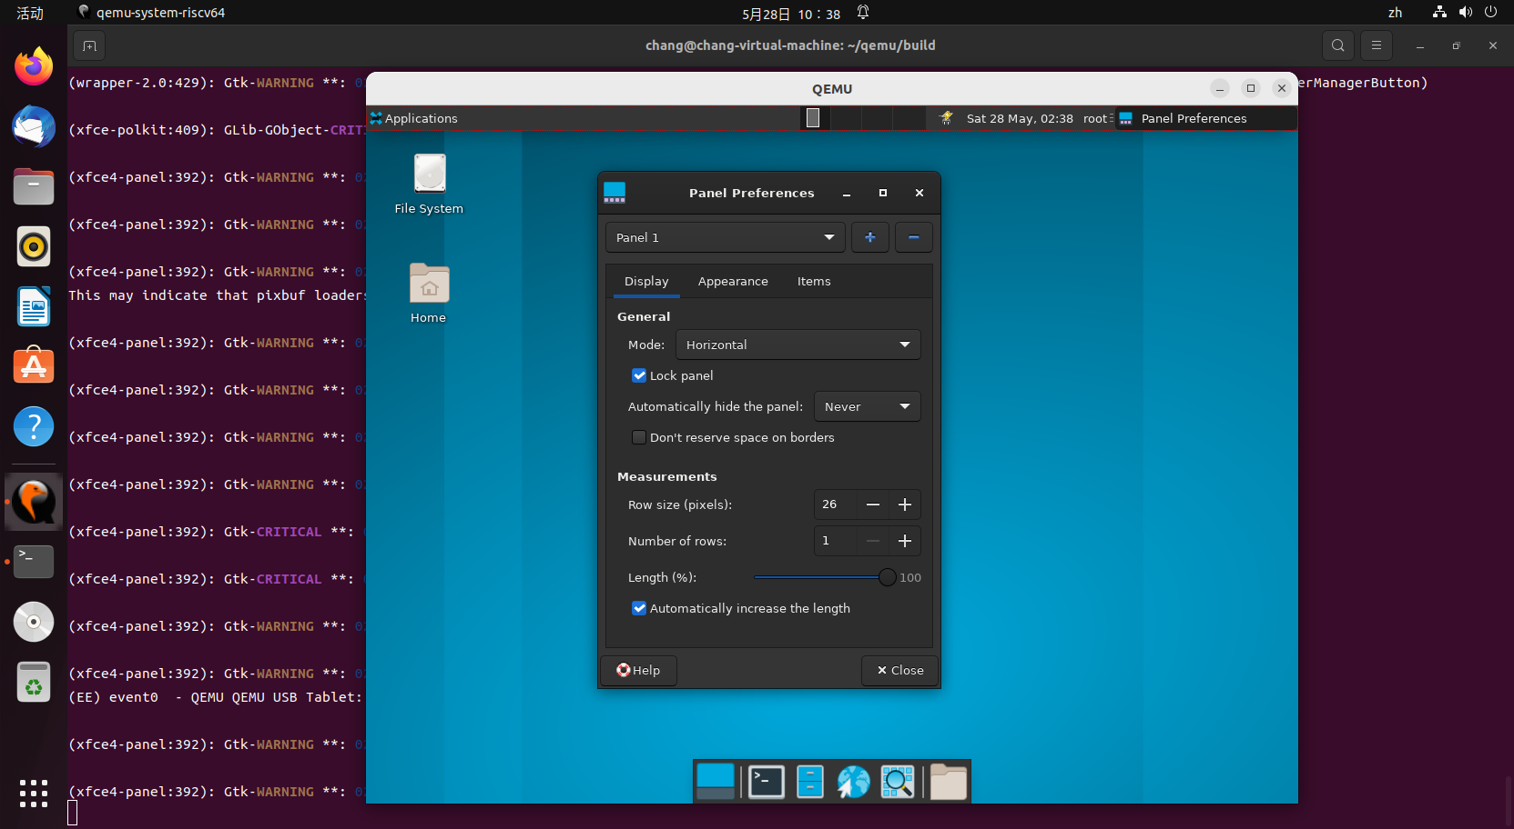

* Panel Appearance下Items页面可正常切换

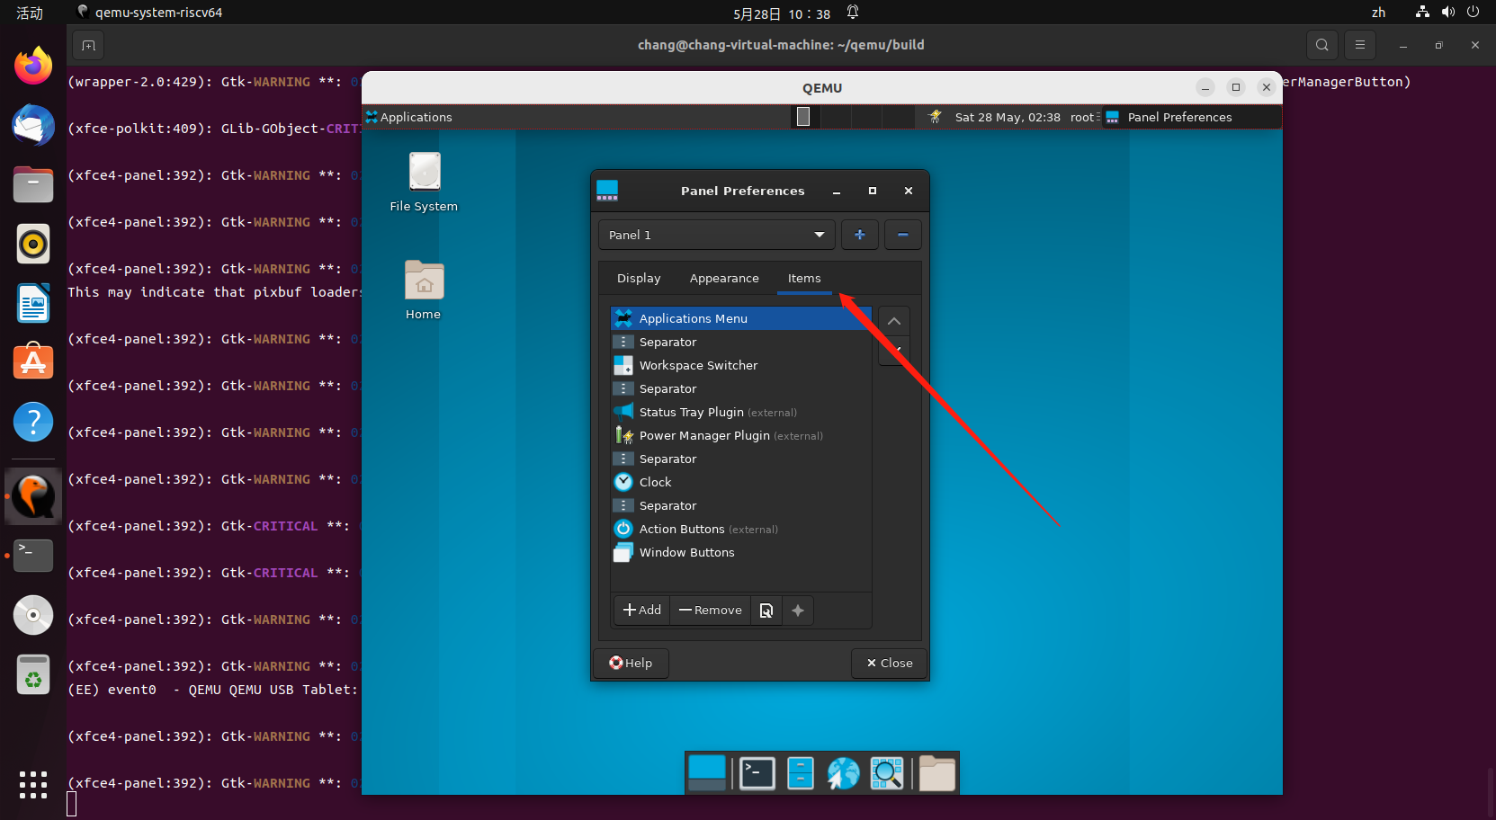

* Panel Appearance-Items-Application Menus测试打开正常

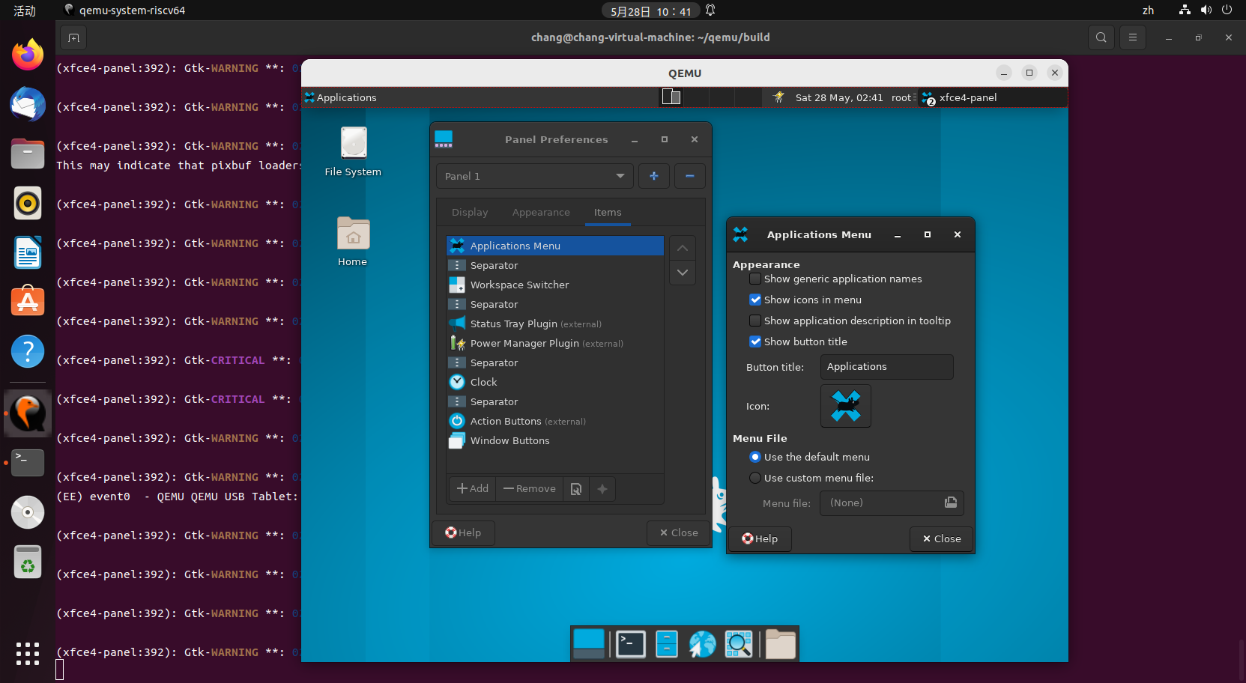

* Panel Appearance-Items-Application Menus-Appearance下按钮勾选正常

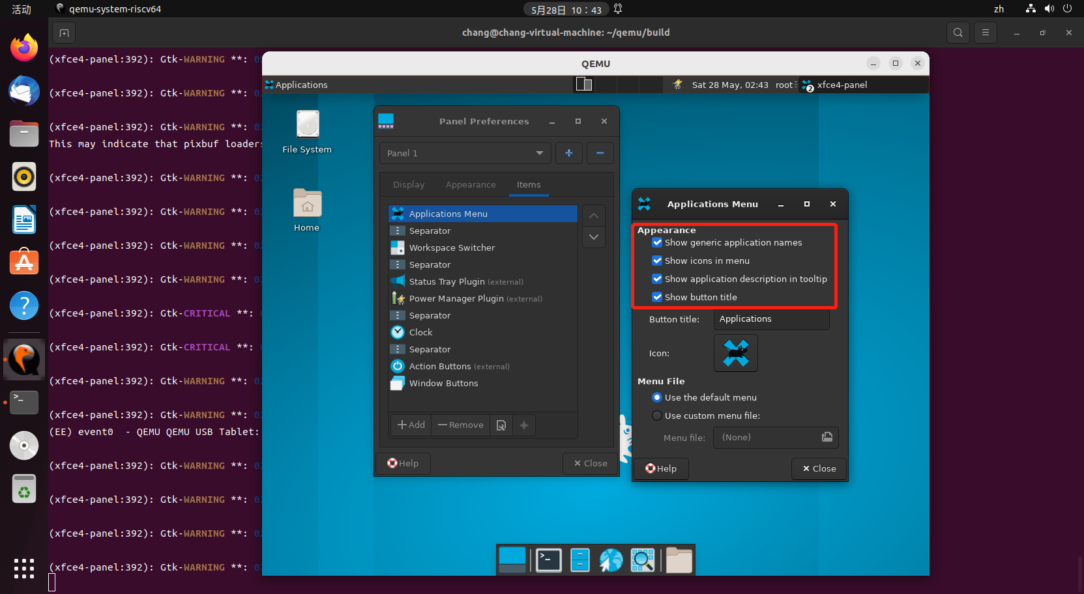

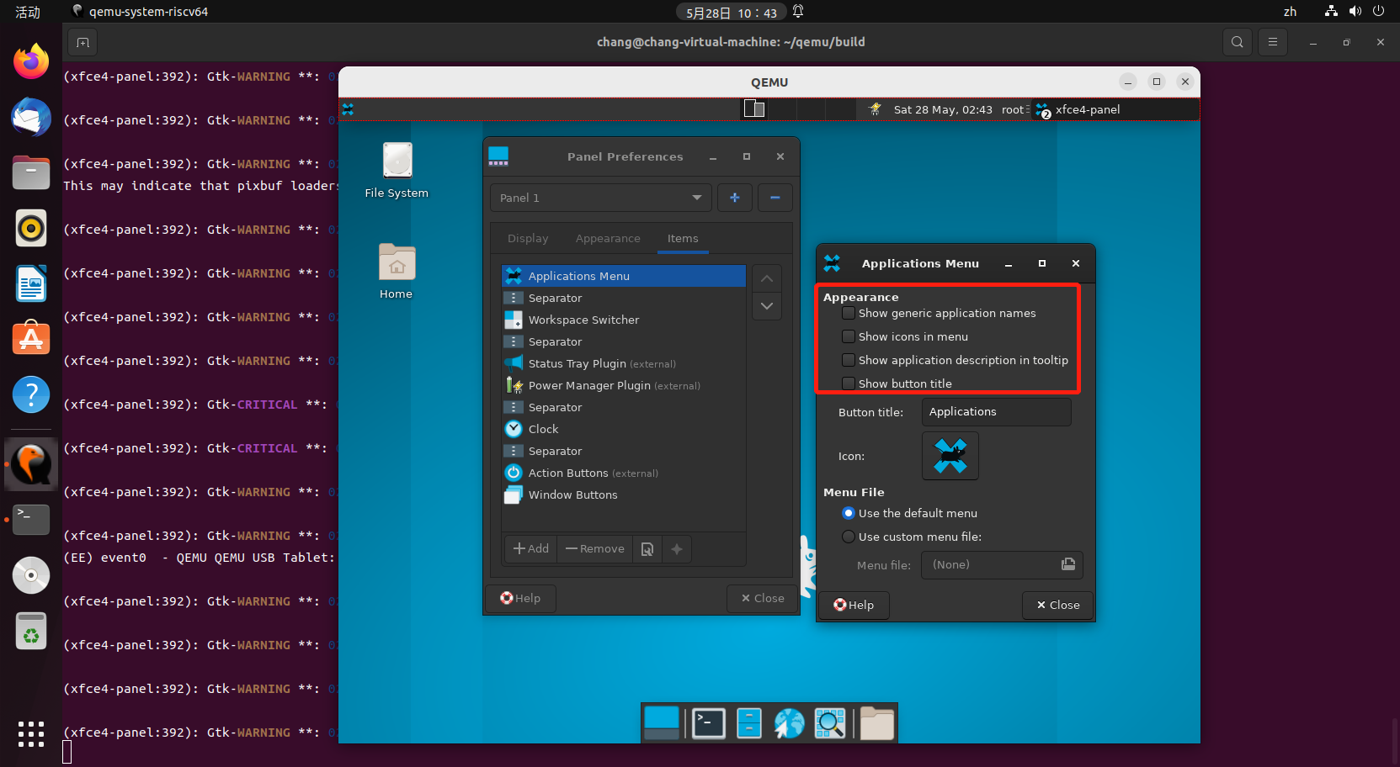

* Panel Appearance-Items-Application Menus-Appearance下按钮标题可正常更改

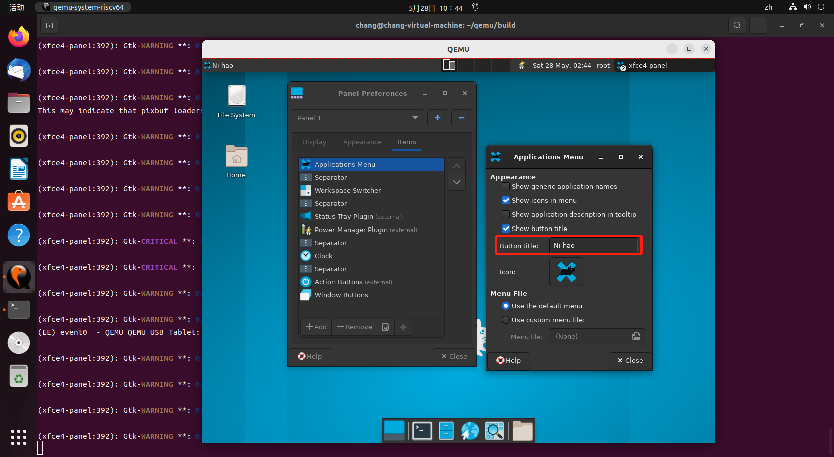

* Panel Appearance-Items-Application Menus-Appearance下按钮图标可正常更改

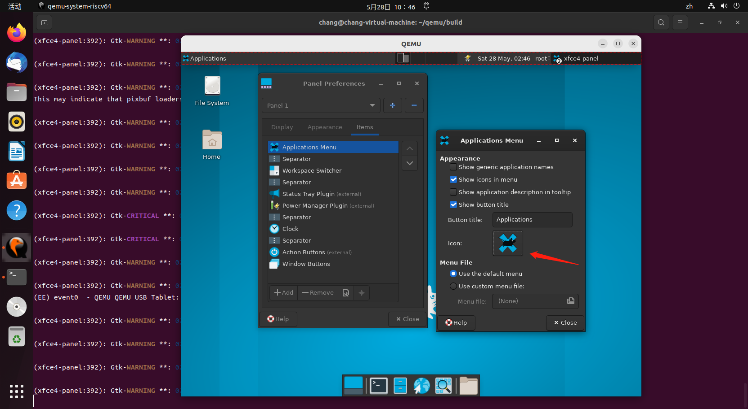

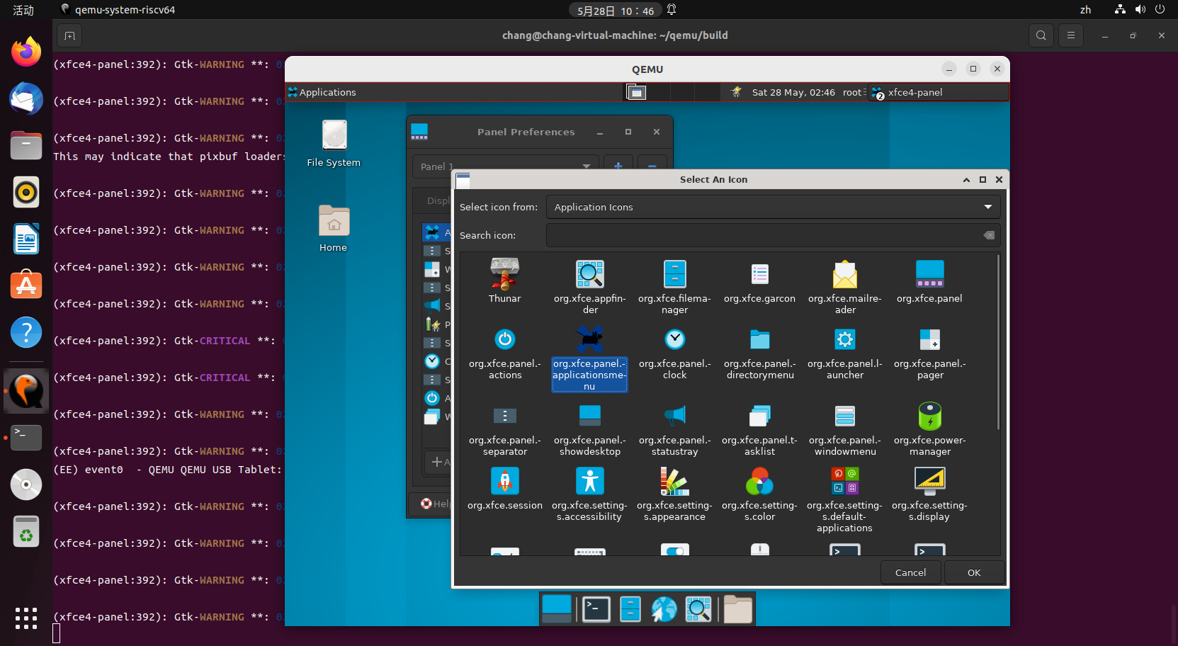

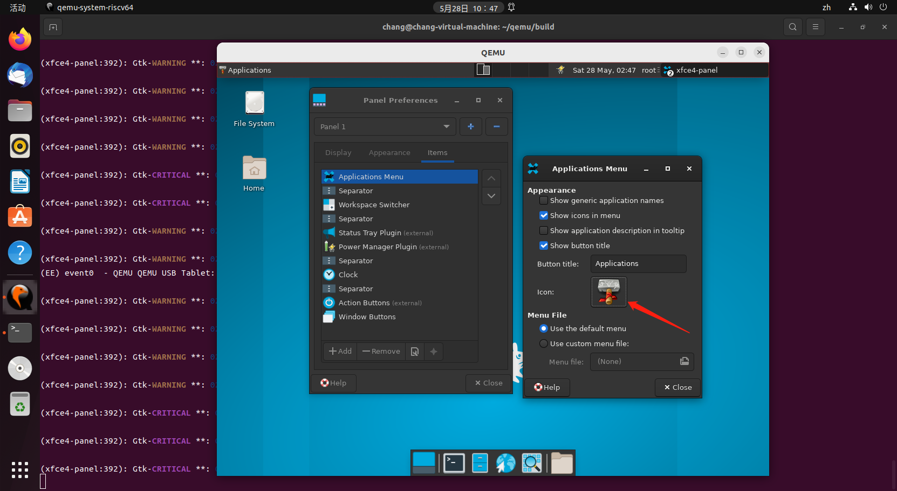

* Panel Appearance-Items-Application Menus-Menu Files可正常选择

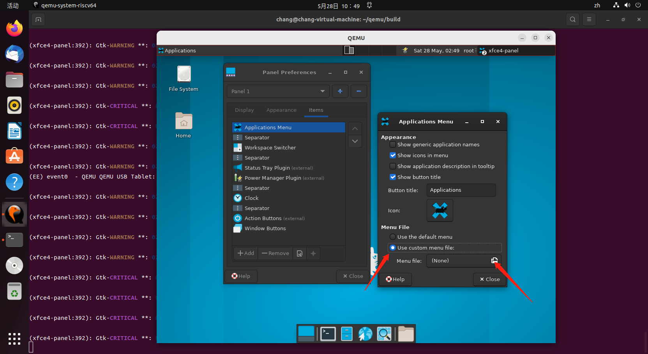

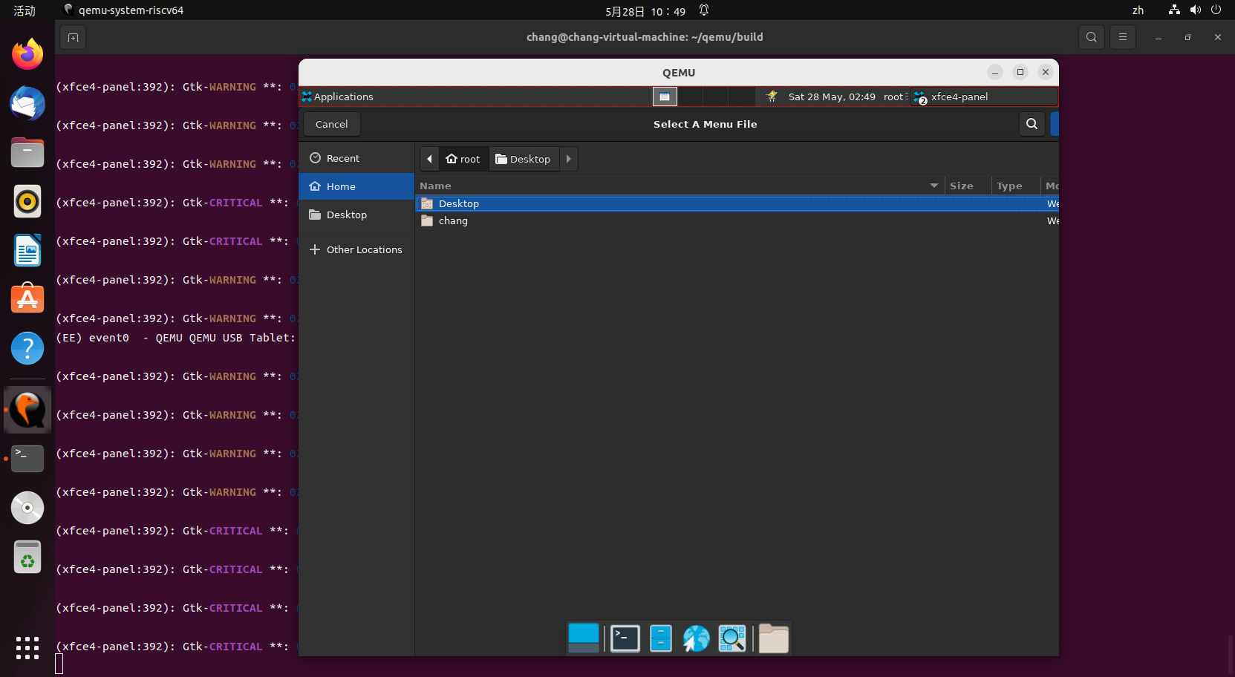

* Panel Appearance-Items-Workspace Switcher打开测试

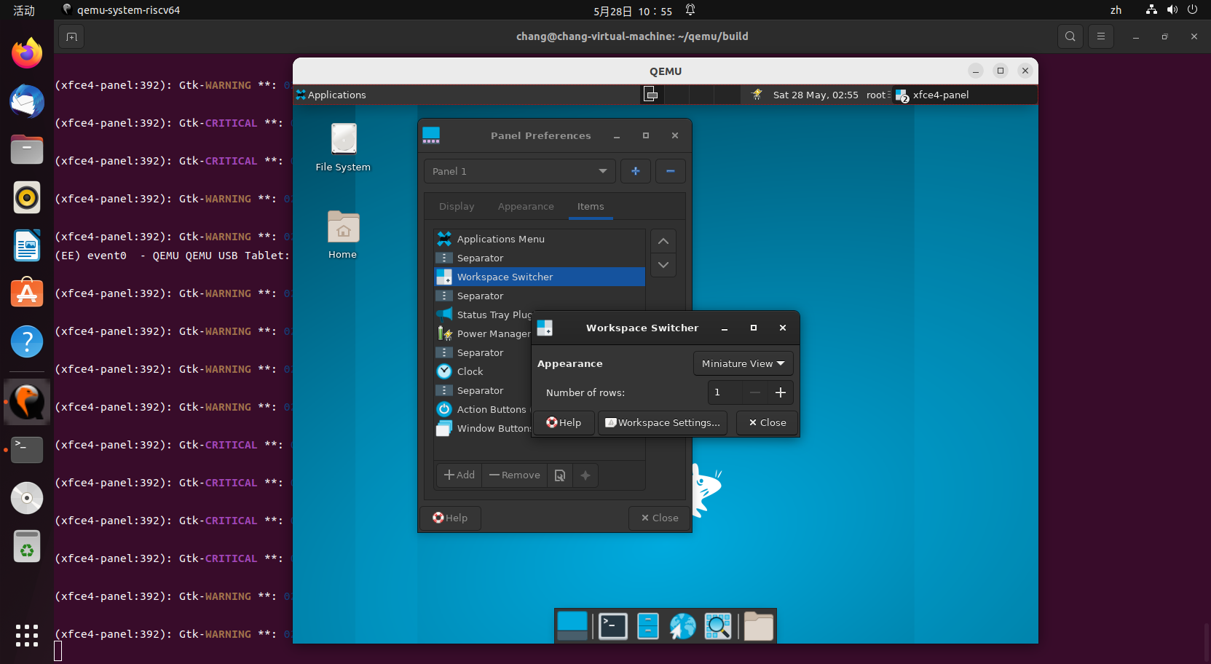

* Panel Appearance-Items-Workspace Switcher-Appearance可正常切换

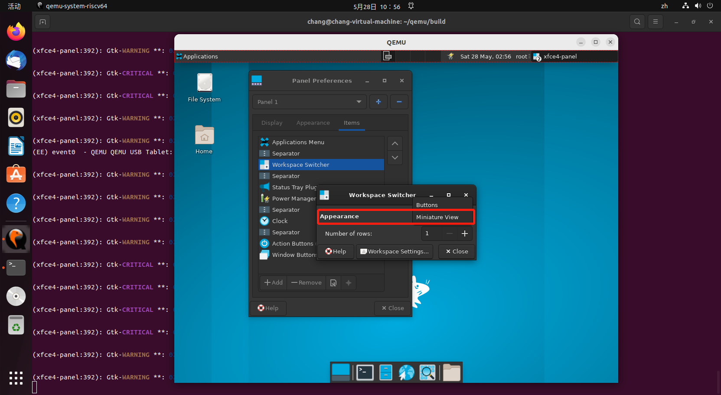

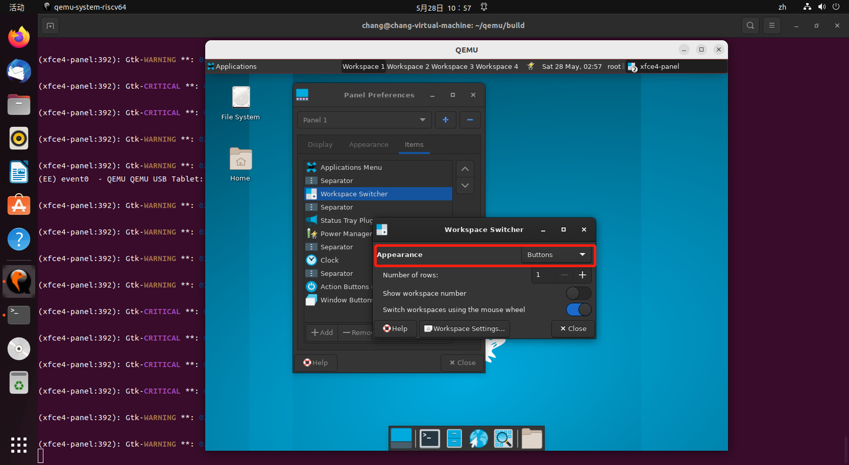

* Panel Appearance-Items-Workspace Switcher-Appearance下number of rows可正常调节

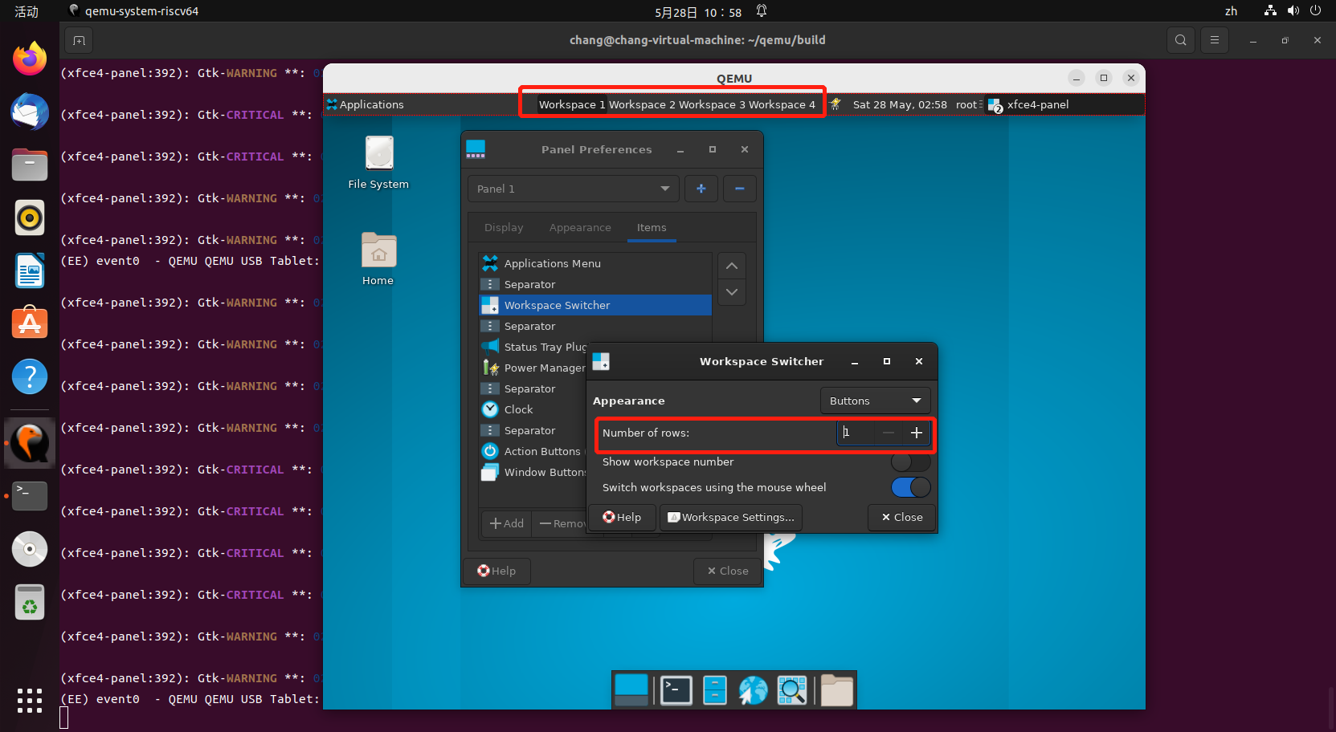

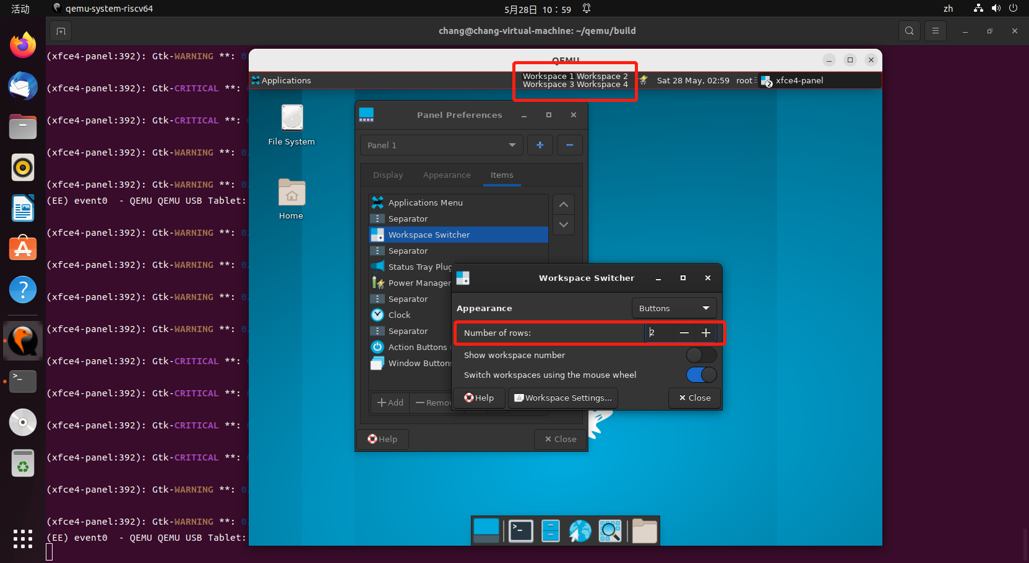

* Panel Appearance-Items-Workspace Switcher-Appearance下按钮可正常调节

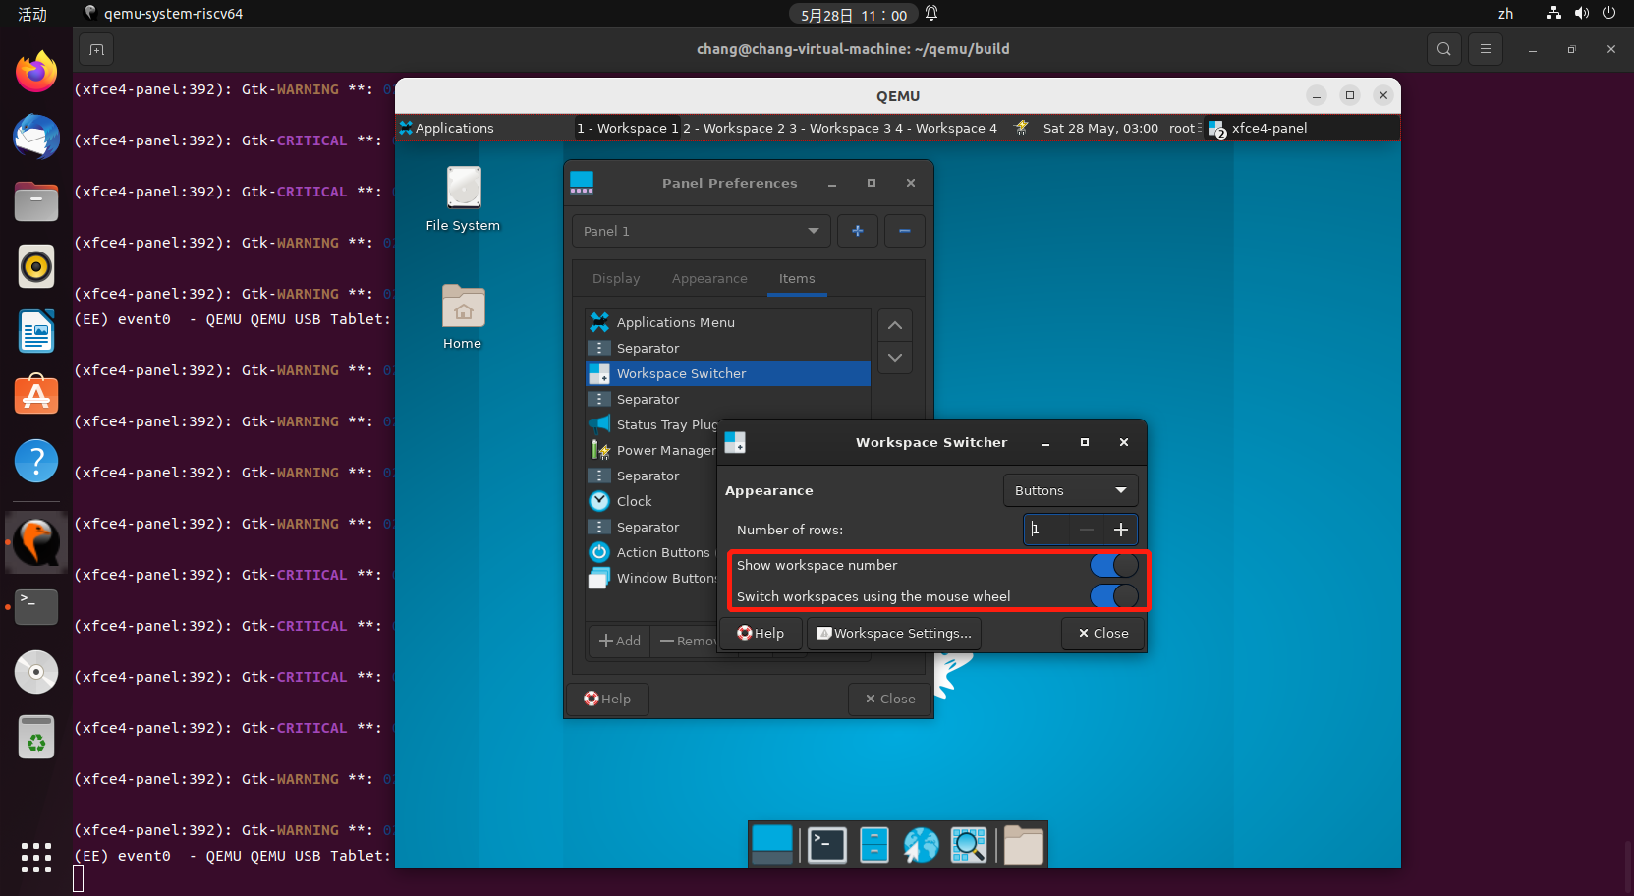

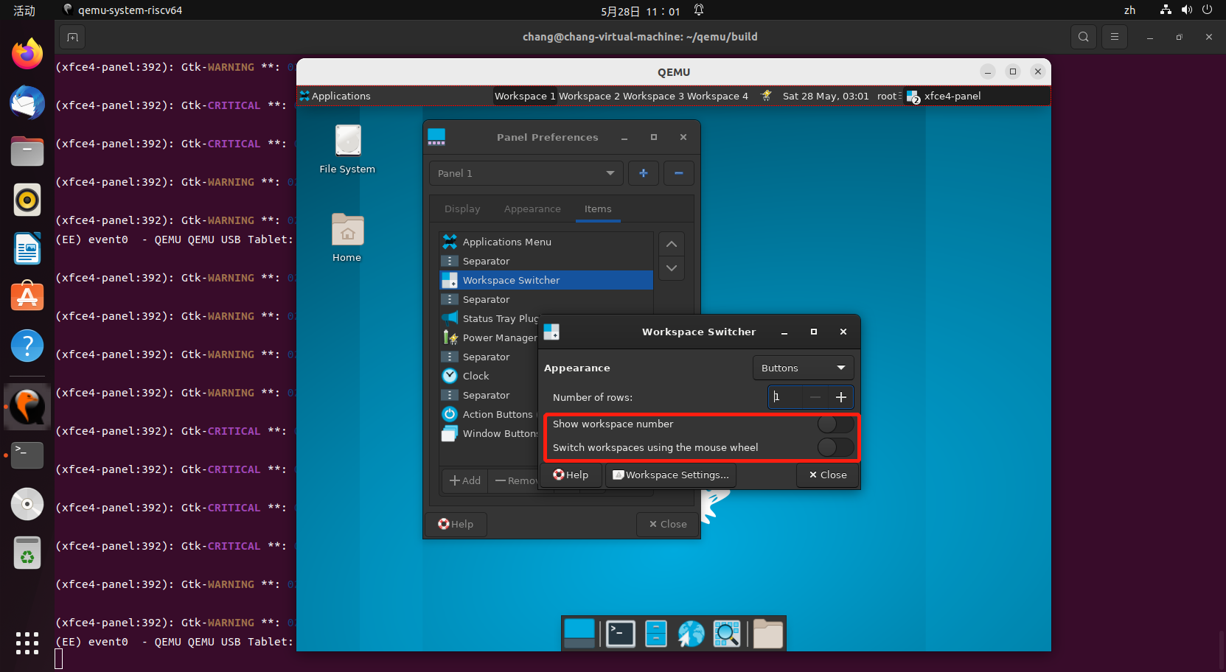

* Panel Appearance-Items-Status Tray Plugin测试

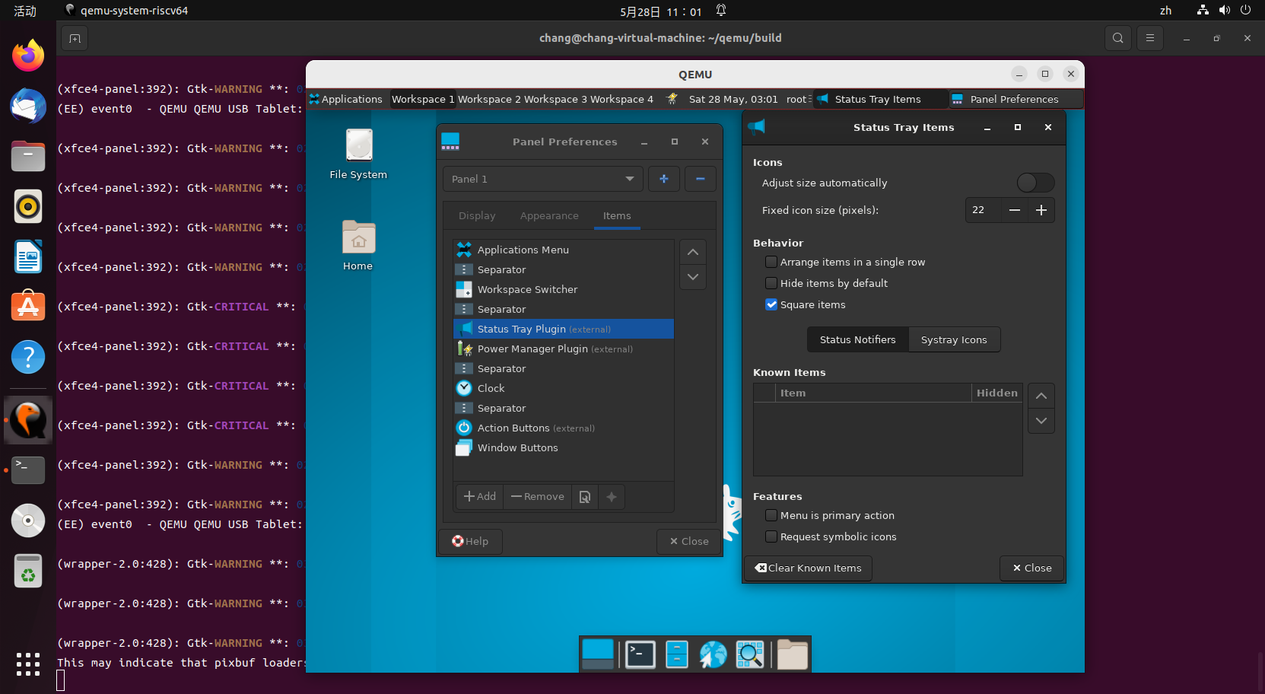

* Panel Appearance-Items-Status Tray Plugin-Icon下图标可正常切换，数值可正常修改

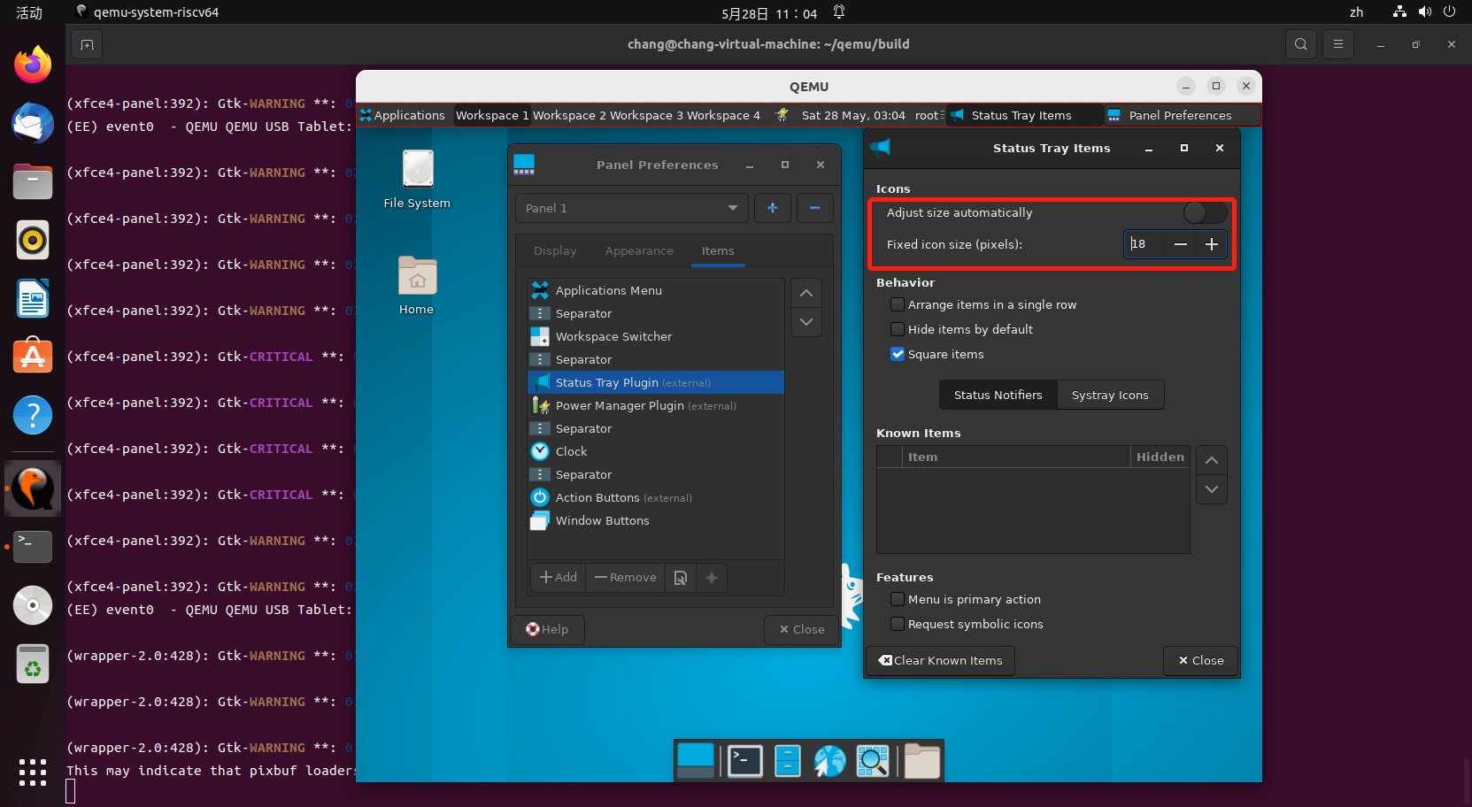

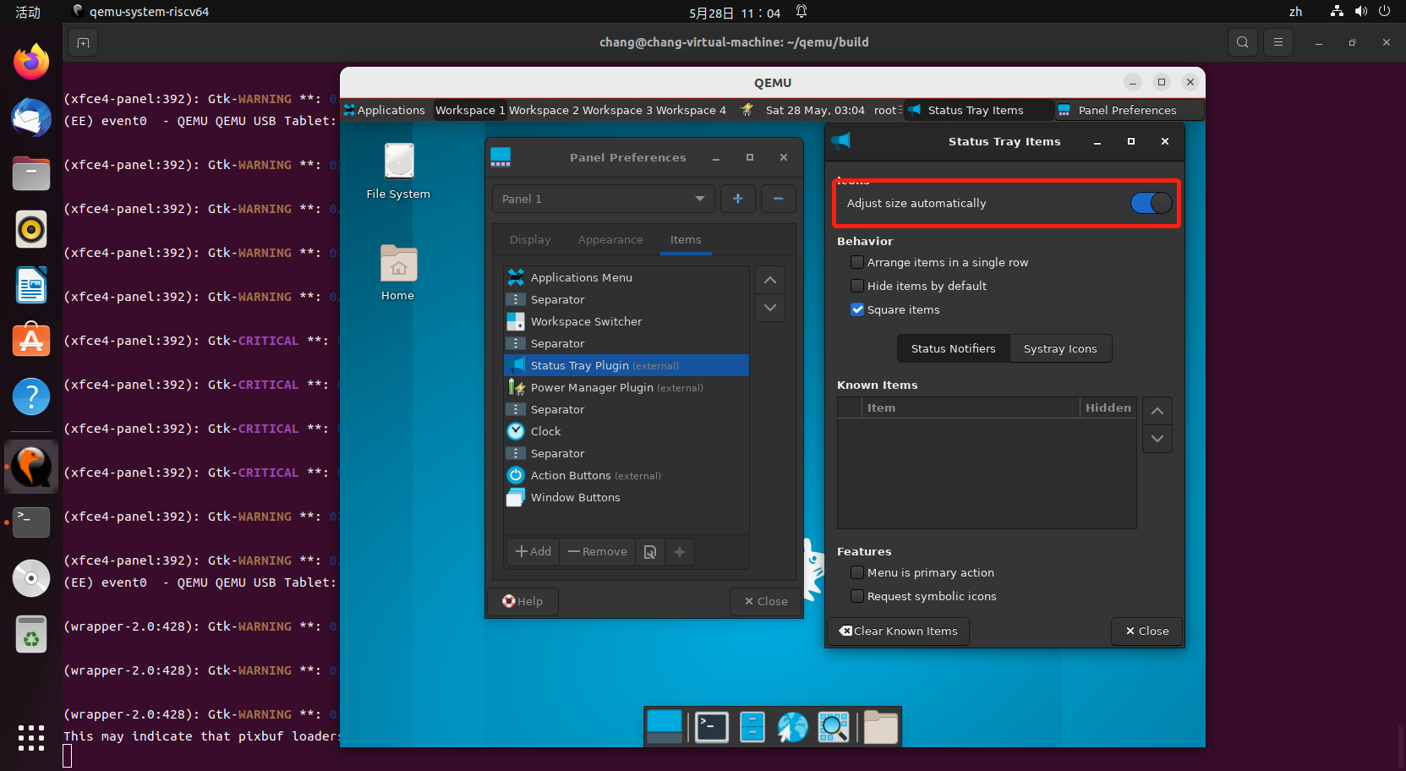

* Panel Appearance-Items-Status Tray Plugin-Behavior下按钮可正常调节

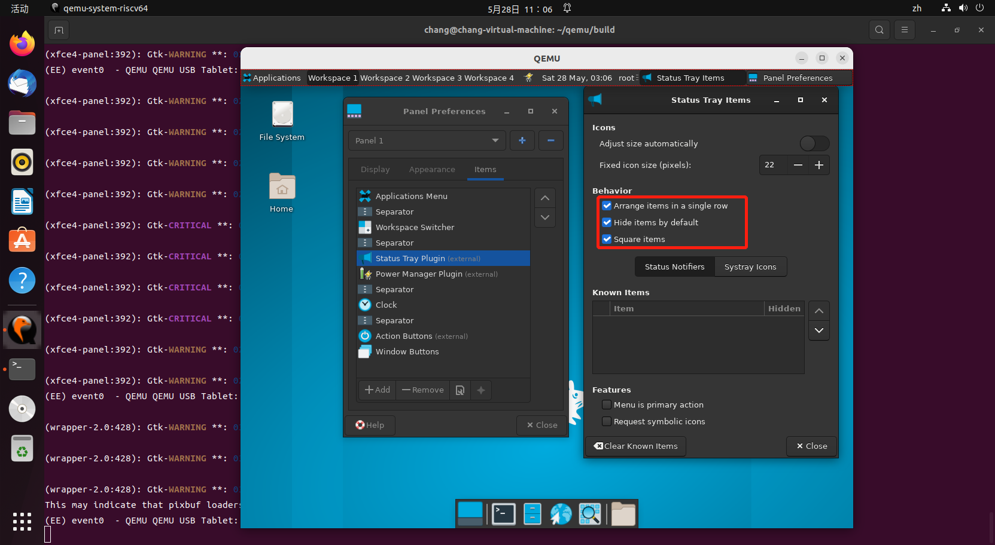

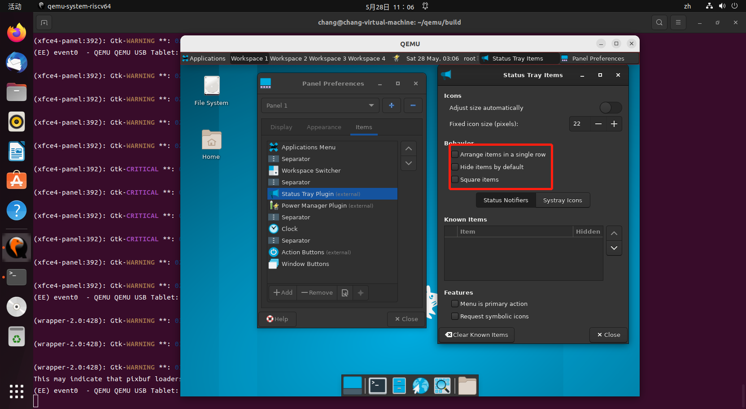

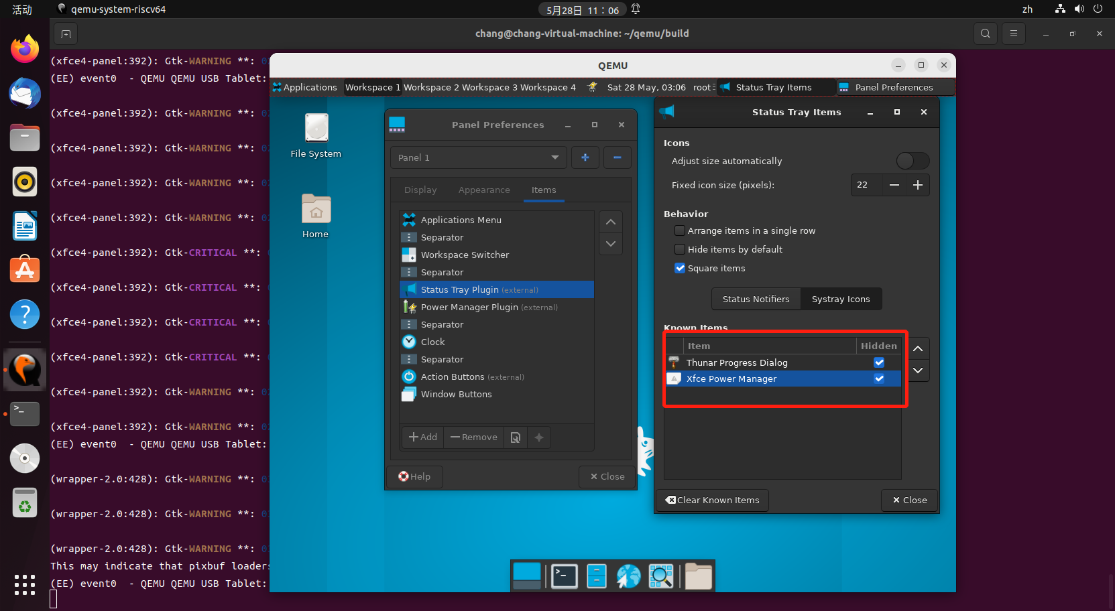

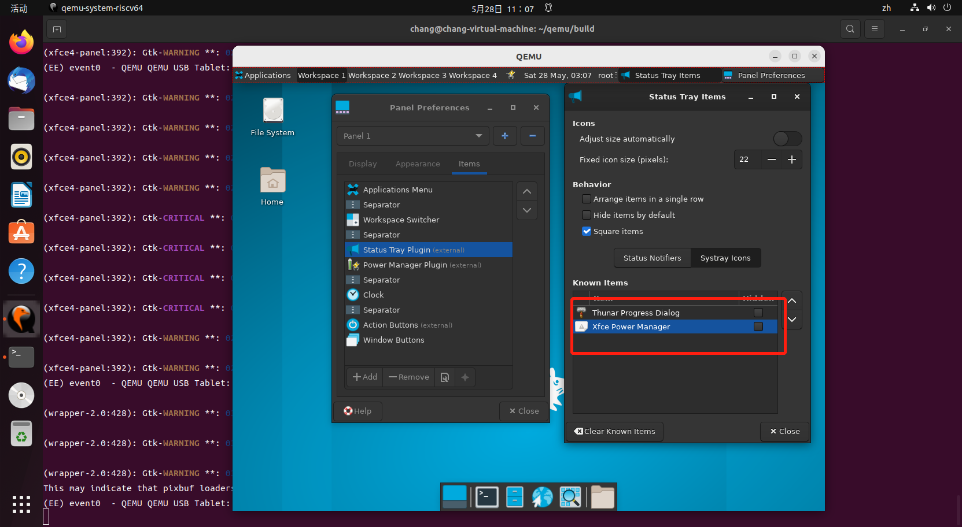

* Panel Appearance-Items-Status Tray Plugin下Clear Known Items测试通过

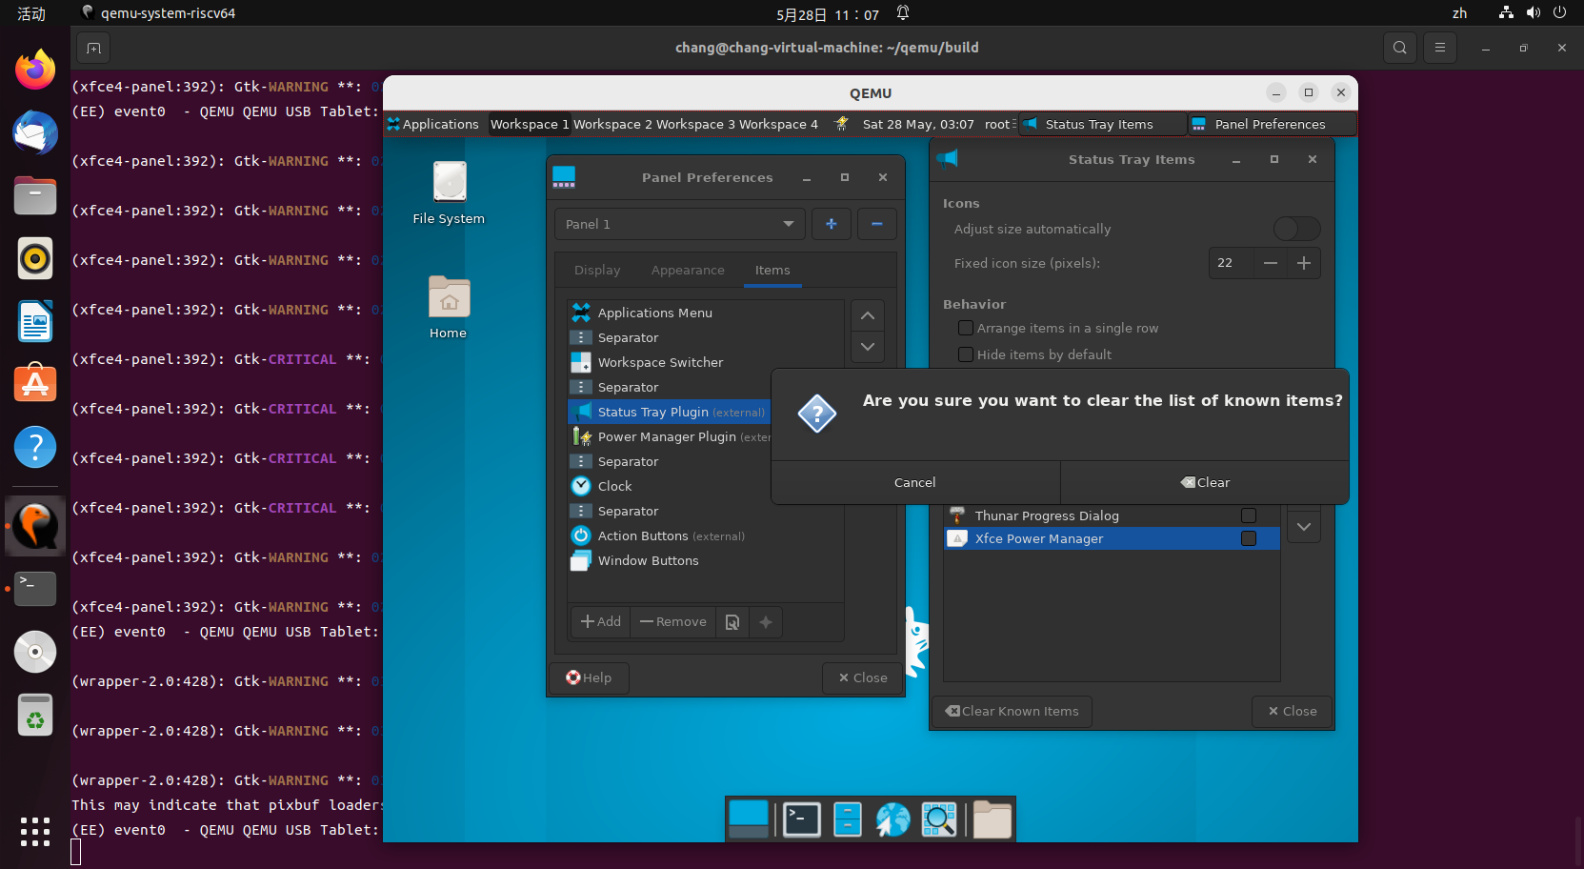

* Panel Appearance-Items-Power Manager Plugin测试

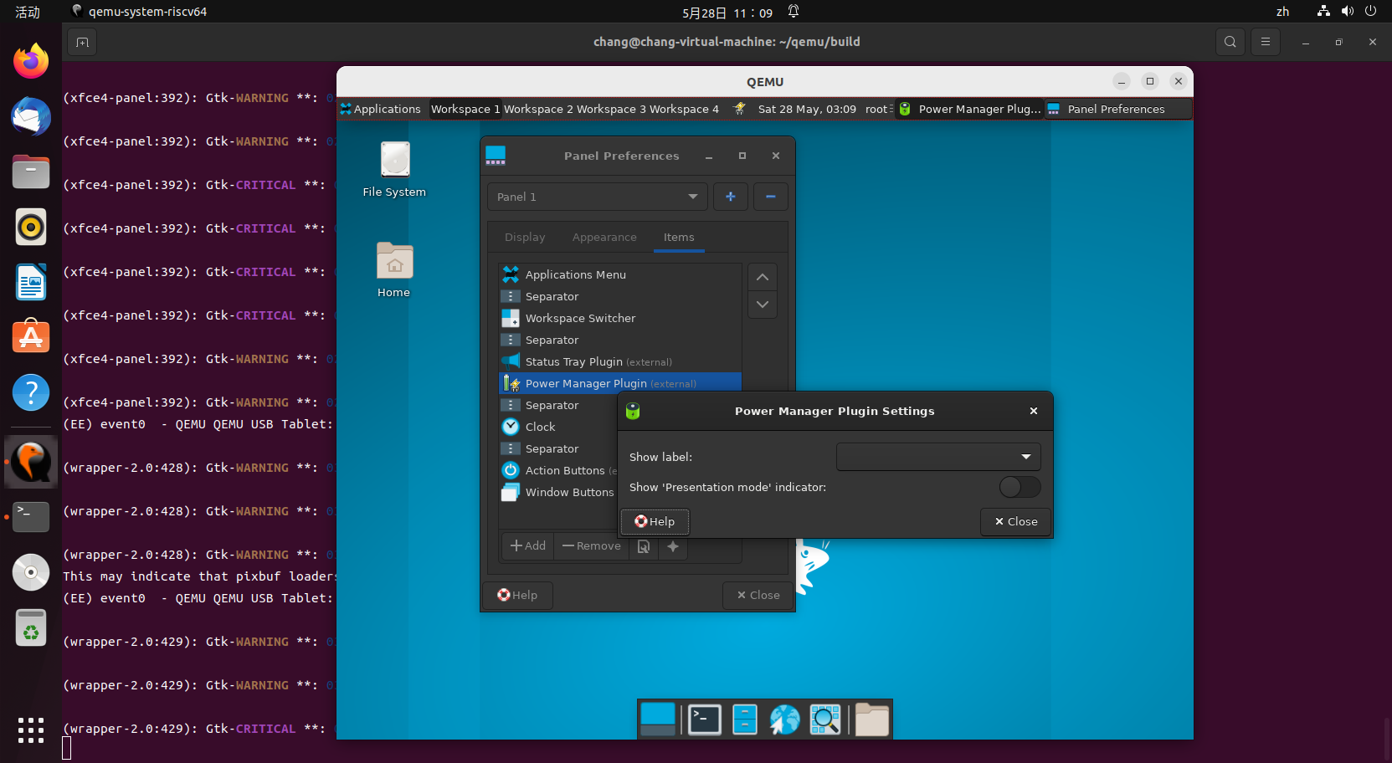

* Panel Appearance-Items-Power Manager Plugin下Show Label可正常切换

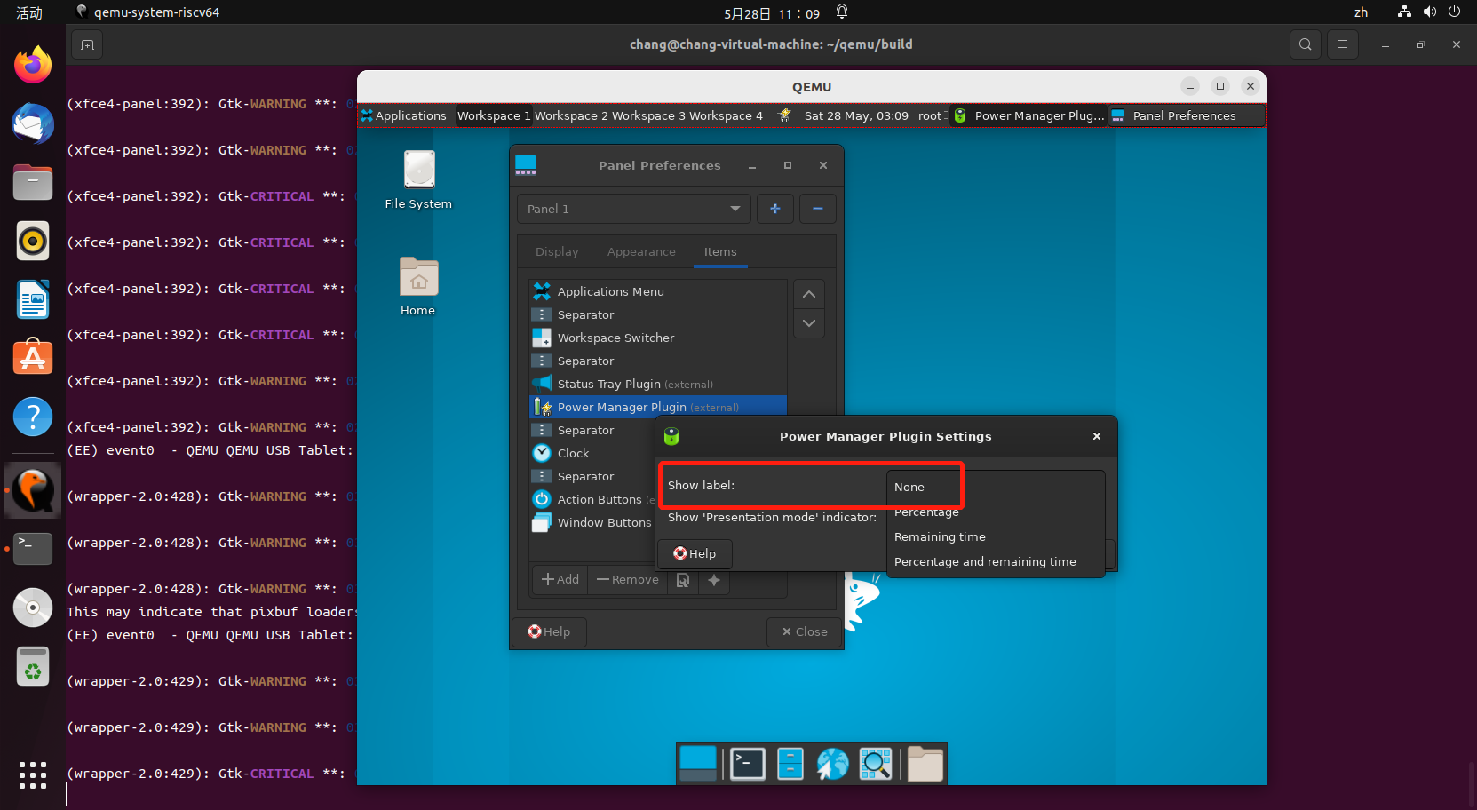

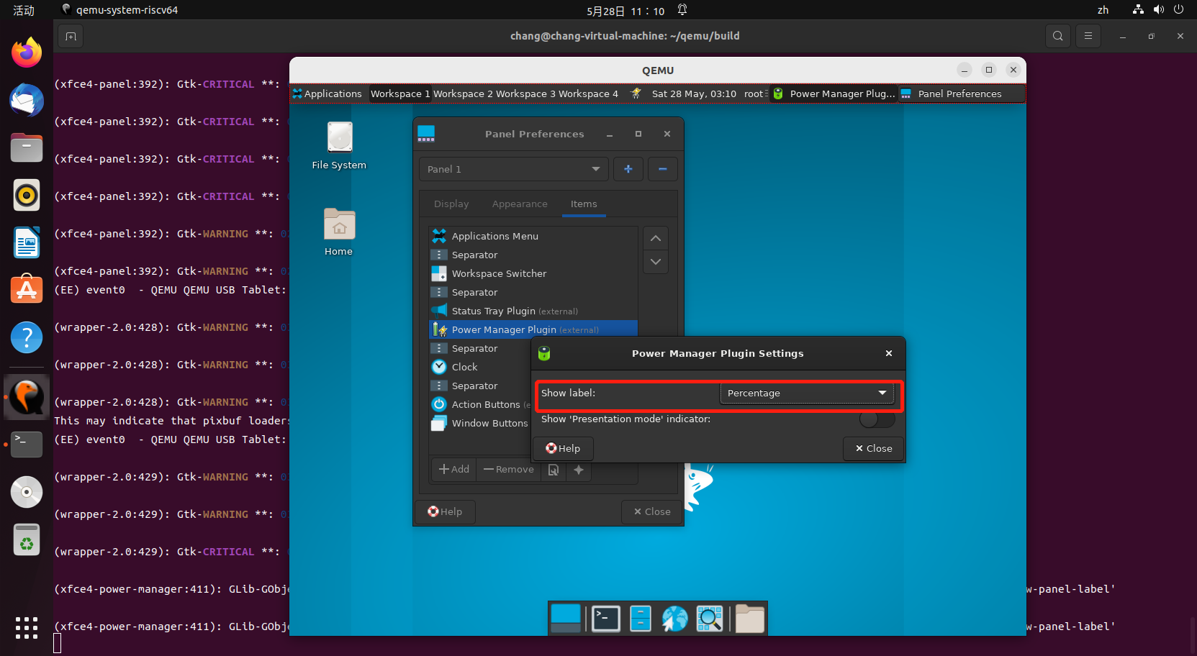

* Panel Appearance-Items-Power Manager Plugin下按钮可正常调节

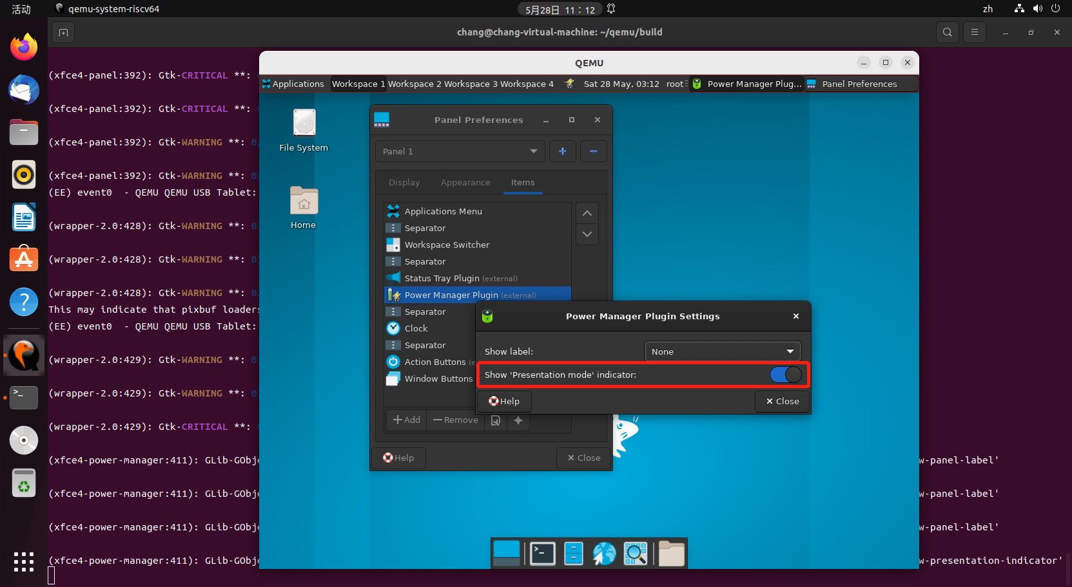

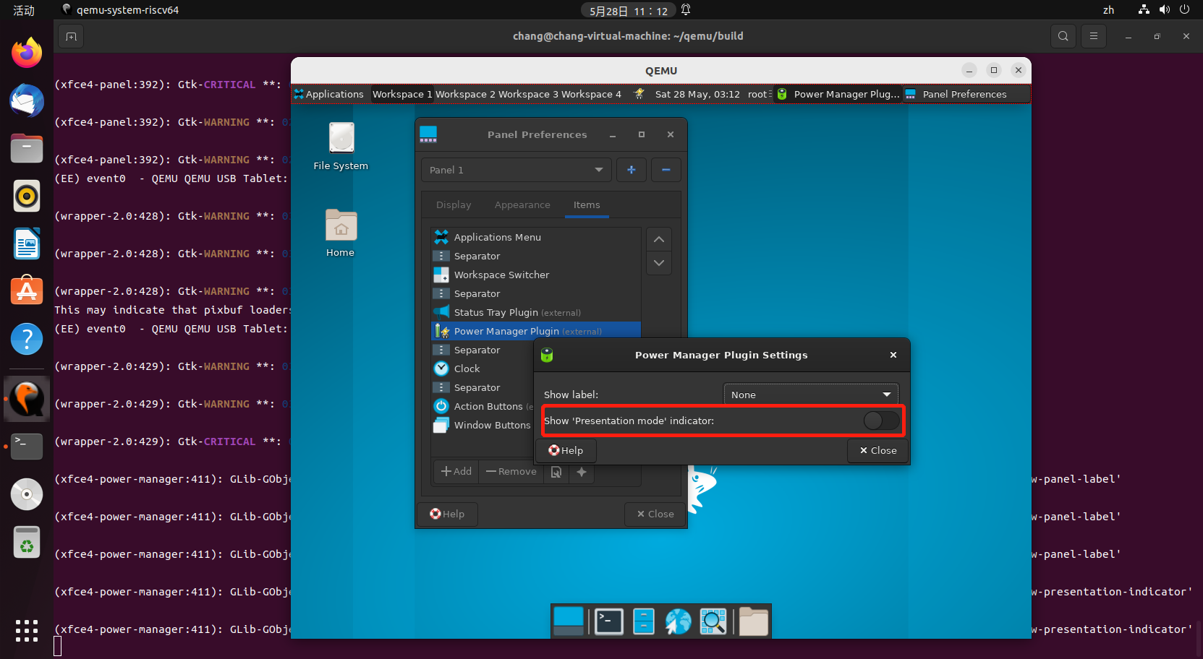

* Panel Appearance-Items-Clock测试

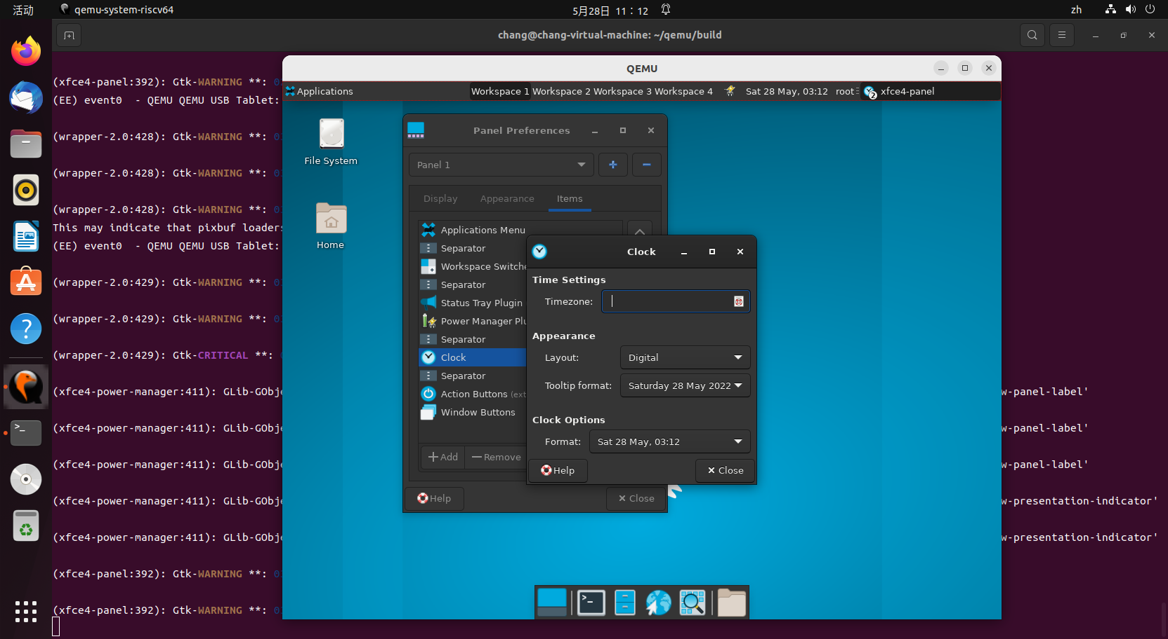

* Panel Appearance-Items-Clock下时区设置通过

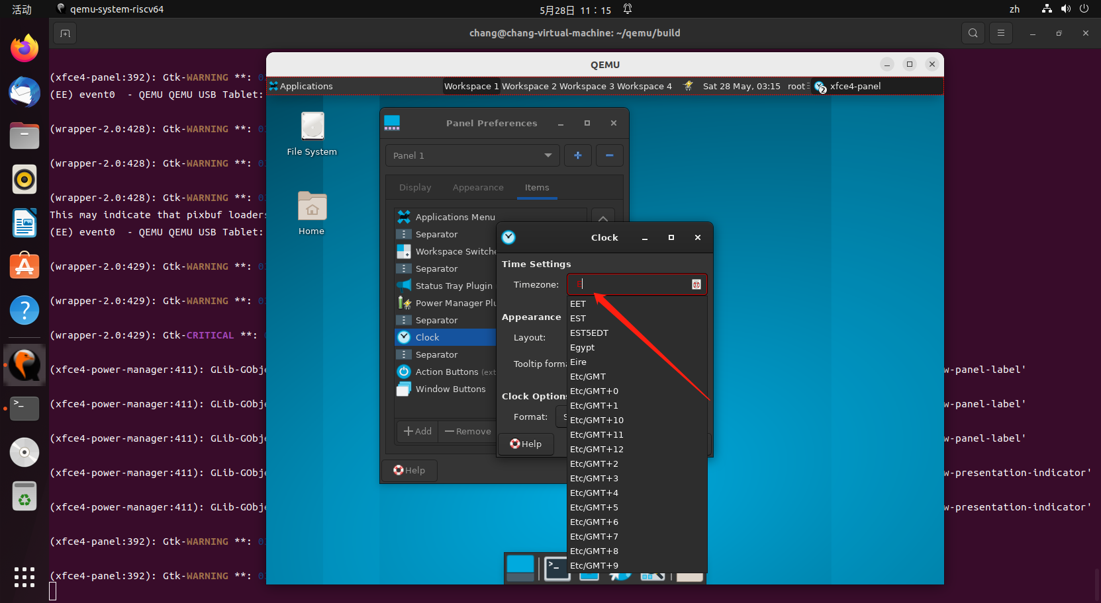

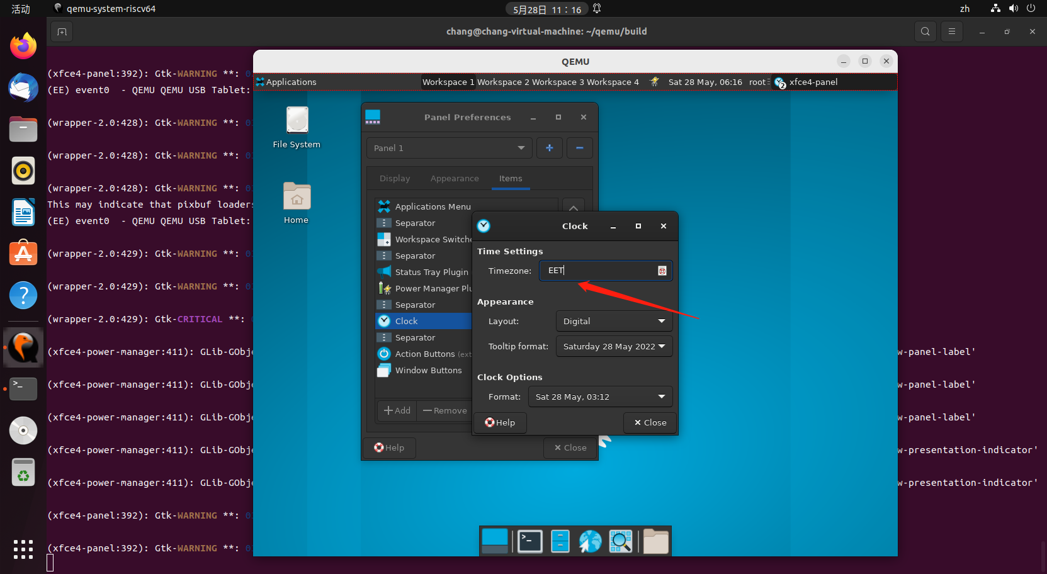

* Panel Appearance-Items-Clock-Appearance下Layout选择测试通过

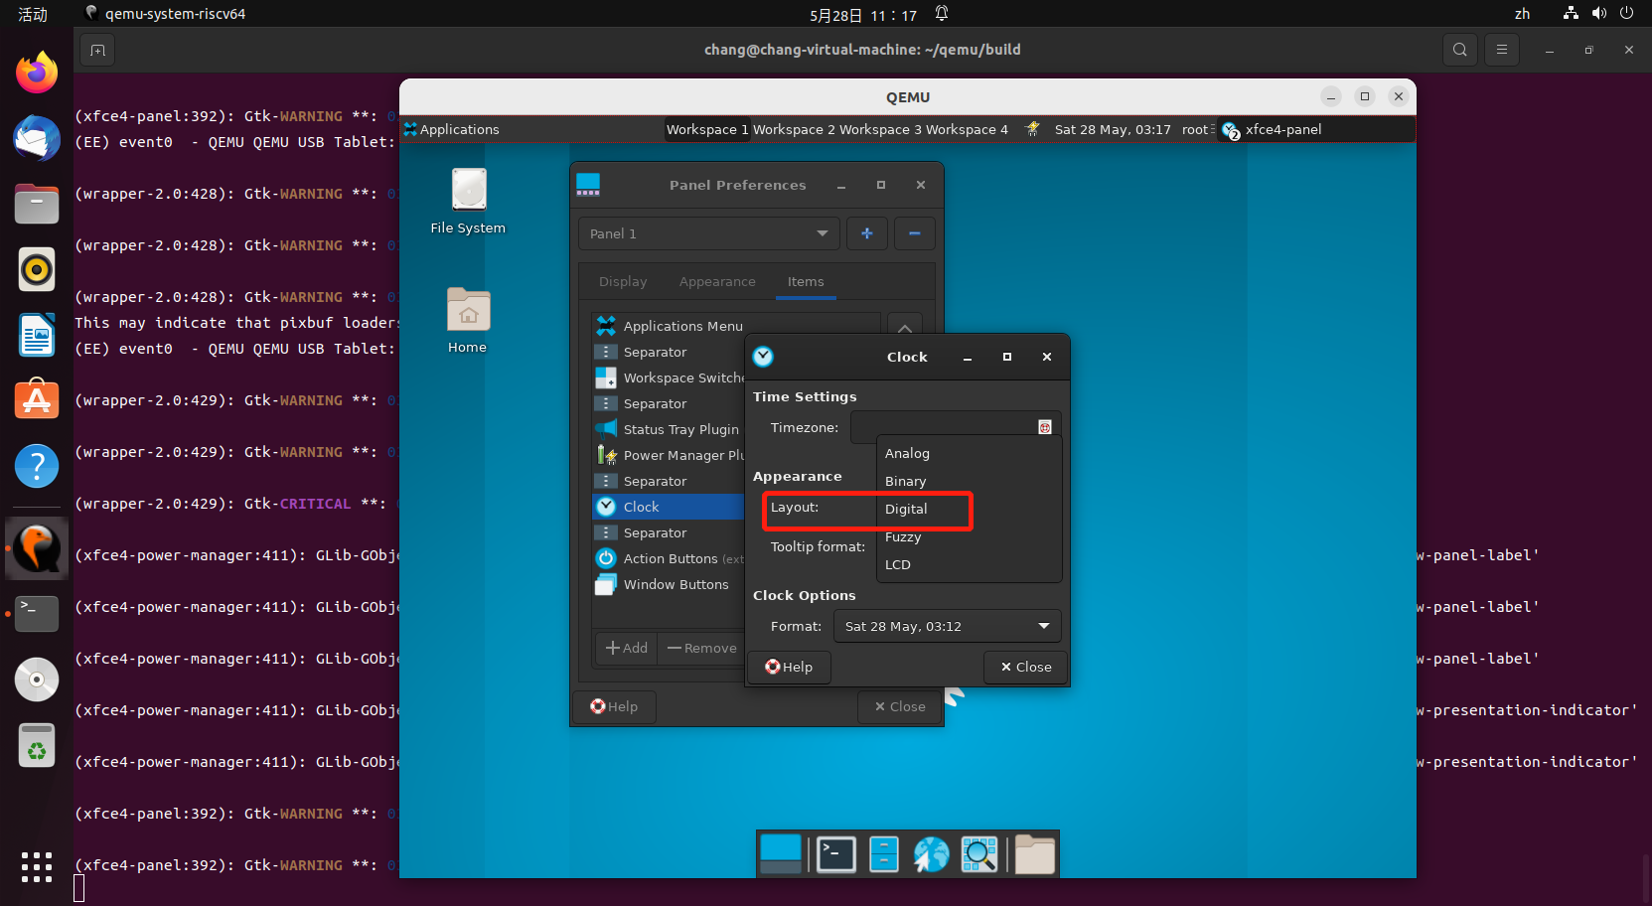

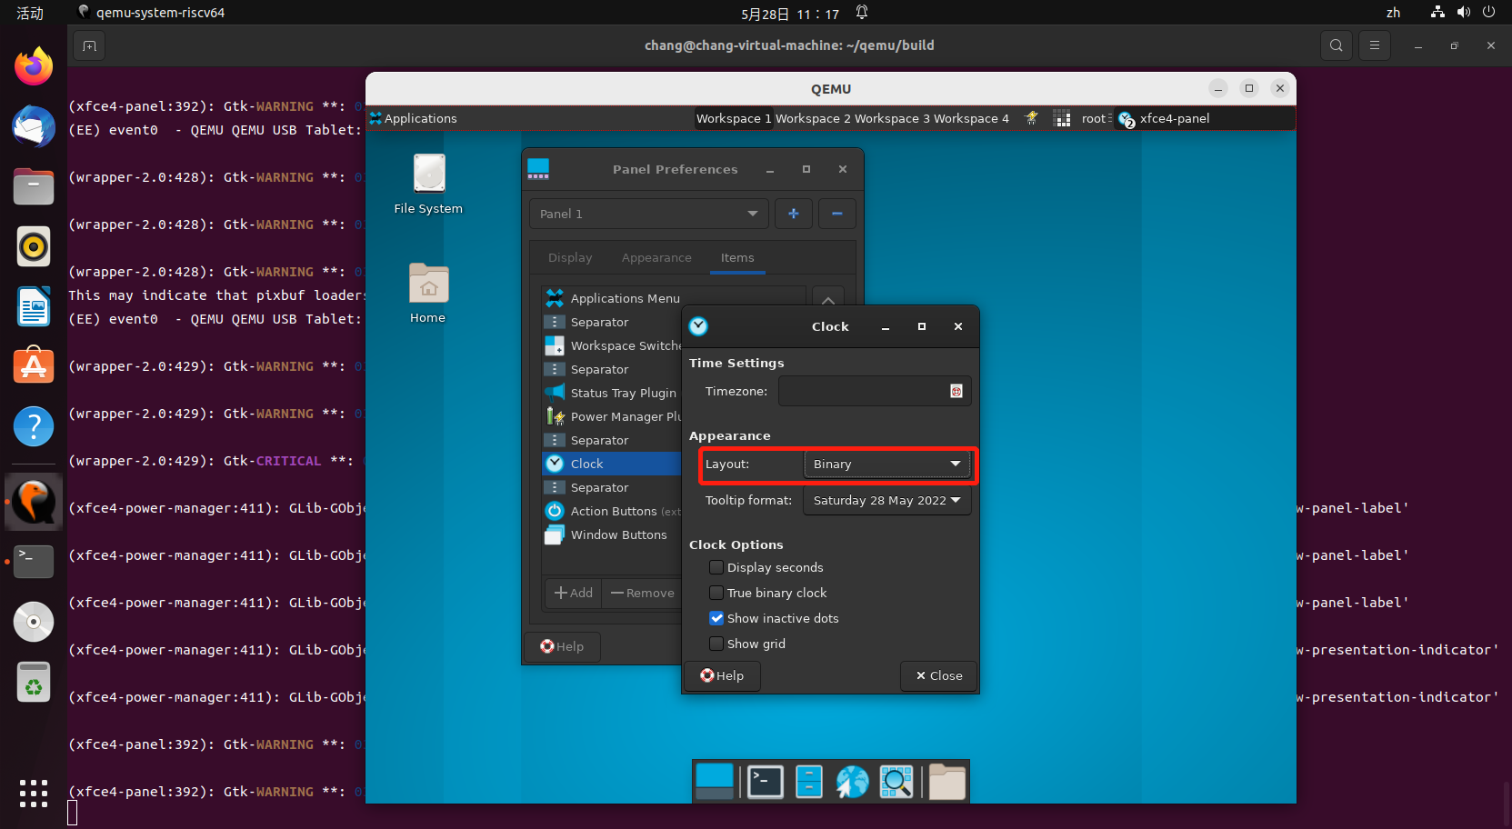

* Panel Appearance-Items-Clock-Appearance下Tooltip Format选择测试通过

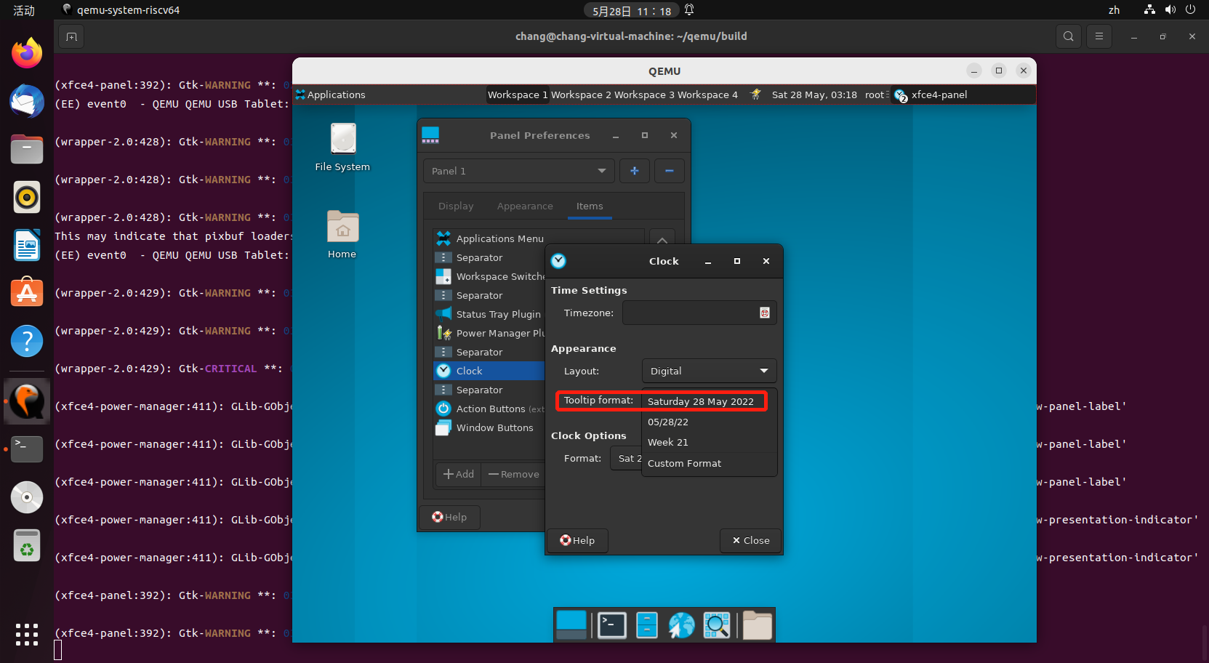

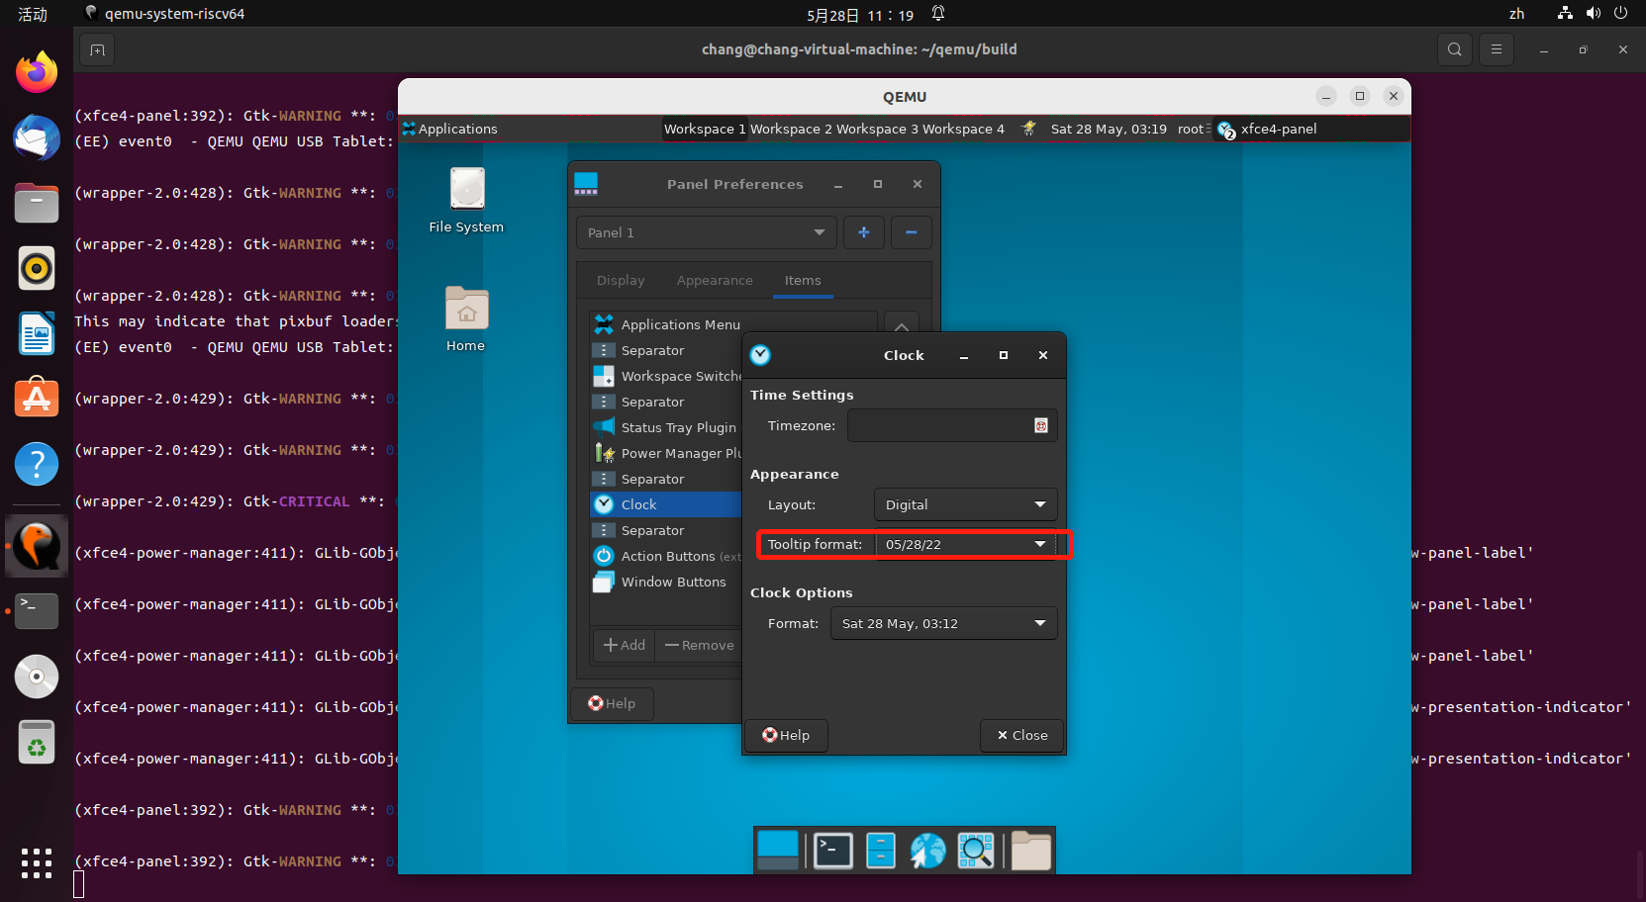

* Panel Appearance-Items-Clock-Clock options选择测试通过

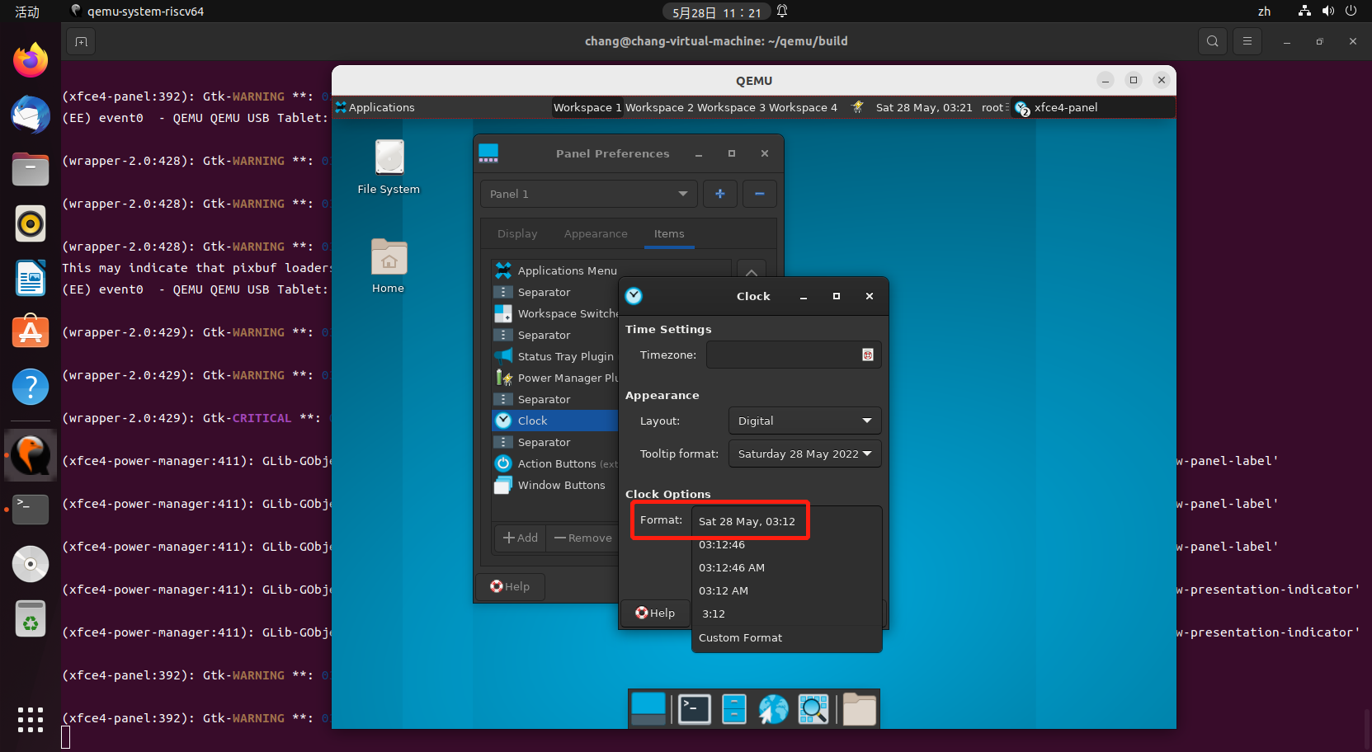

* Panel Appearance-Items-Action Buttons测试

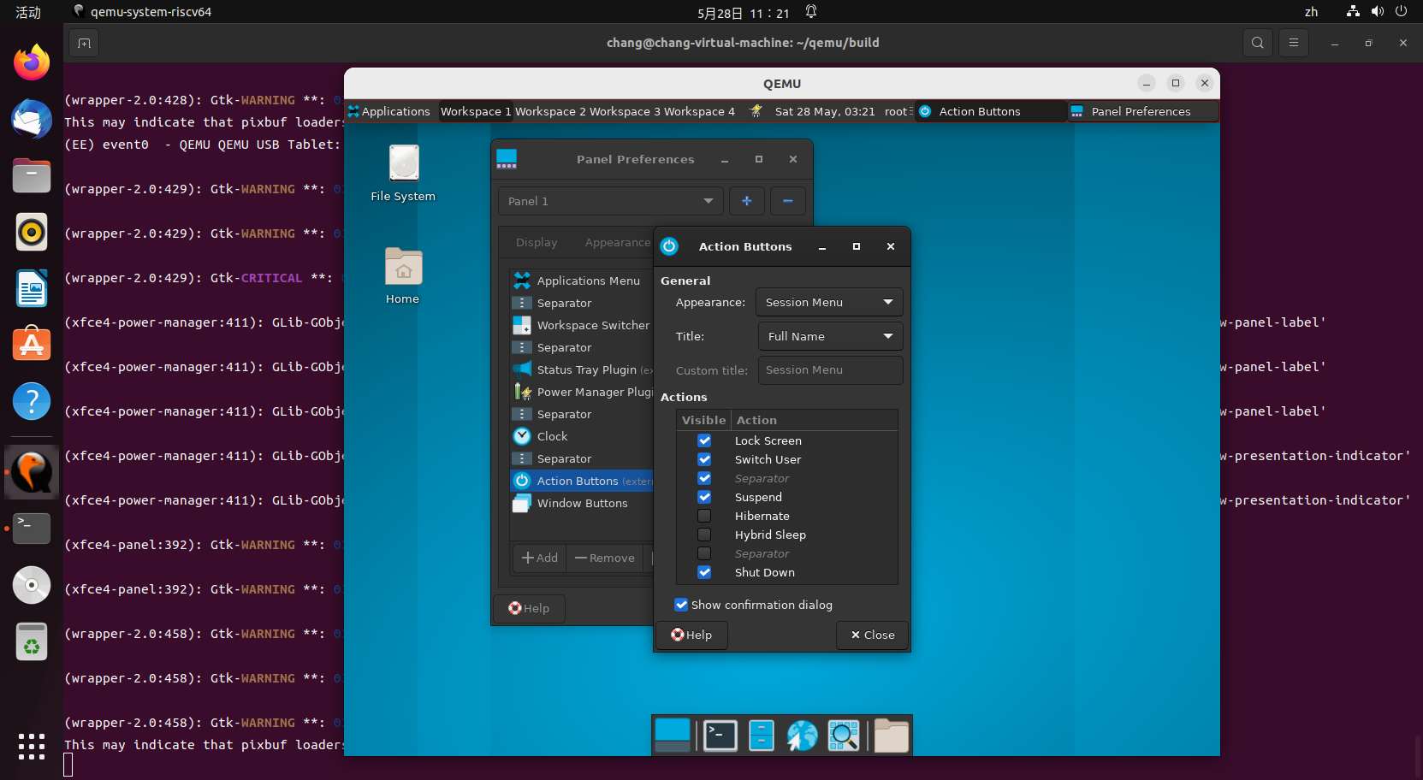

* Panel Appearance-Items-Action Buttons-General下Appearance和Title可正常选择

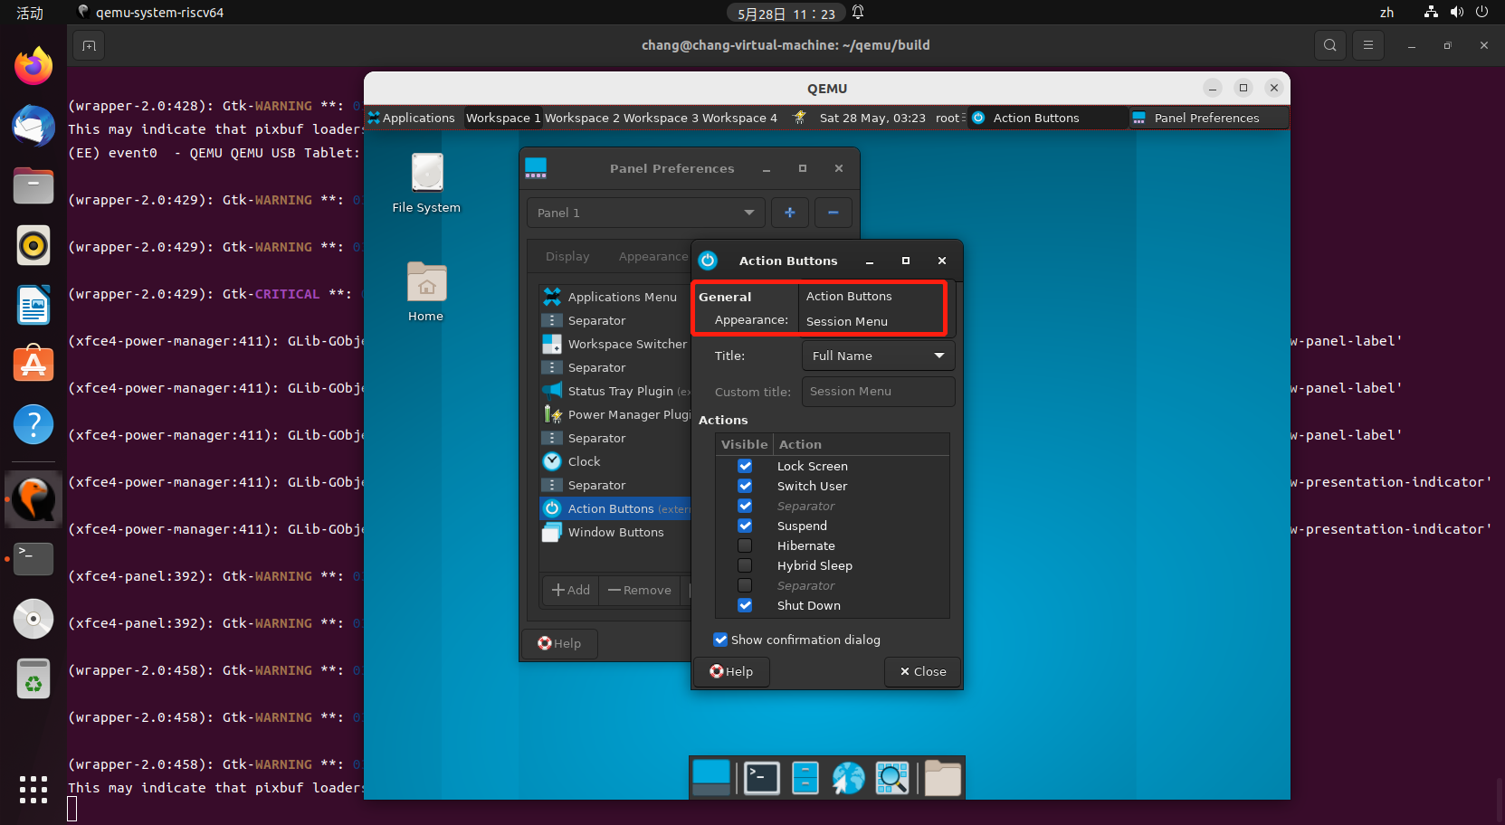

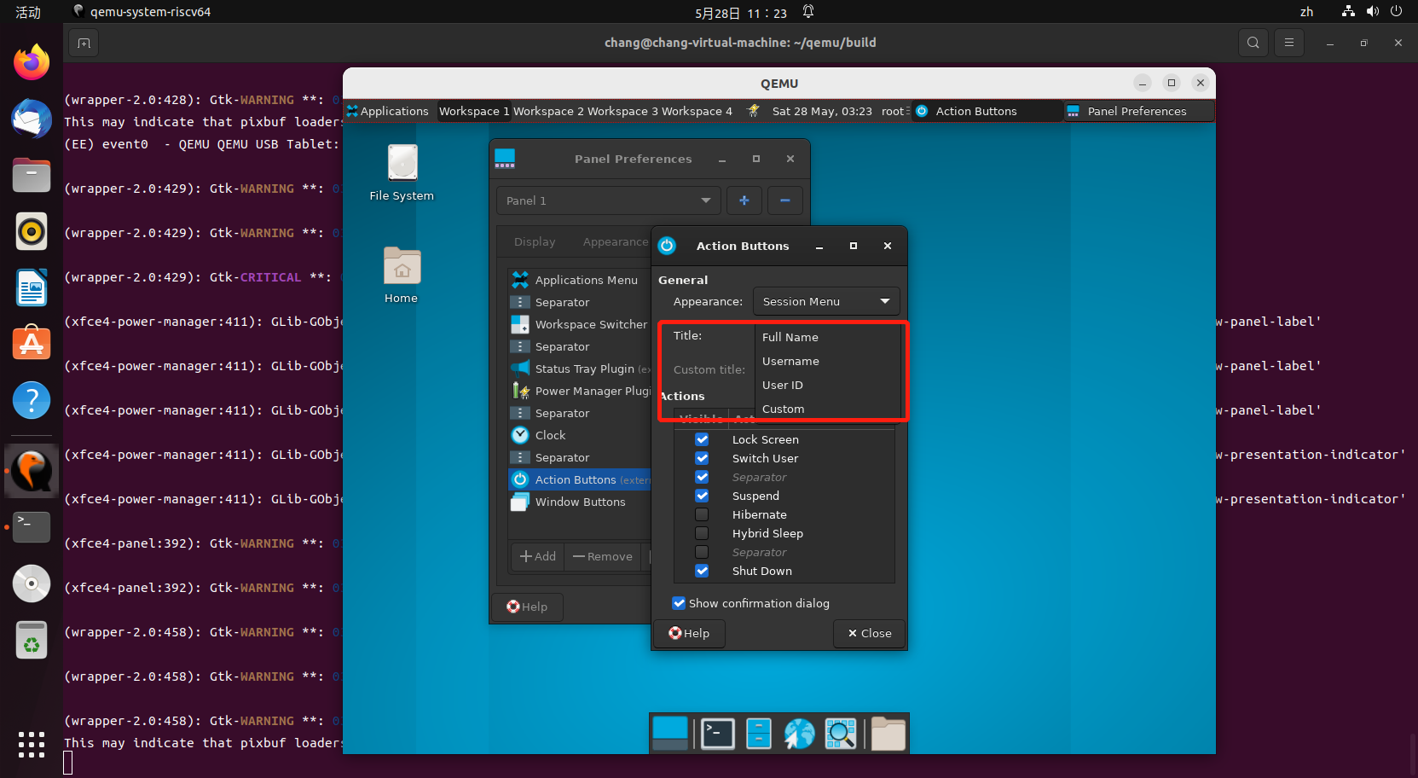

* Panel Appearance-Items-Action Buttons-Action下按钮勾选正常

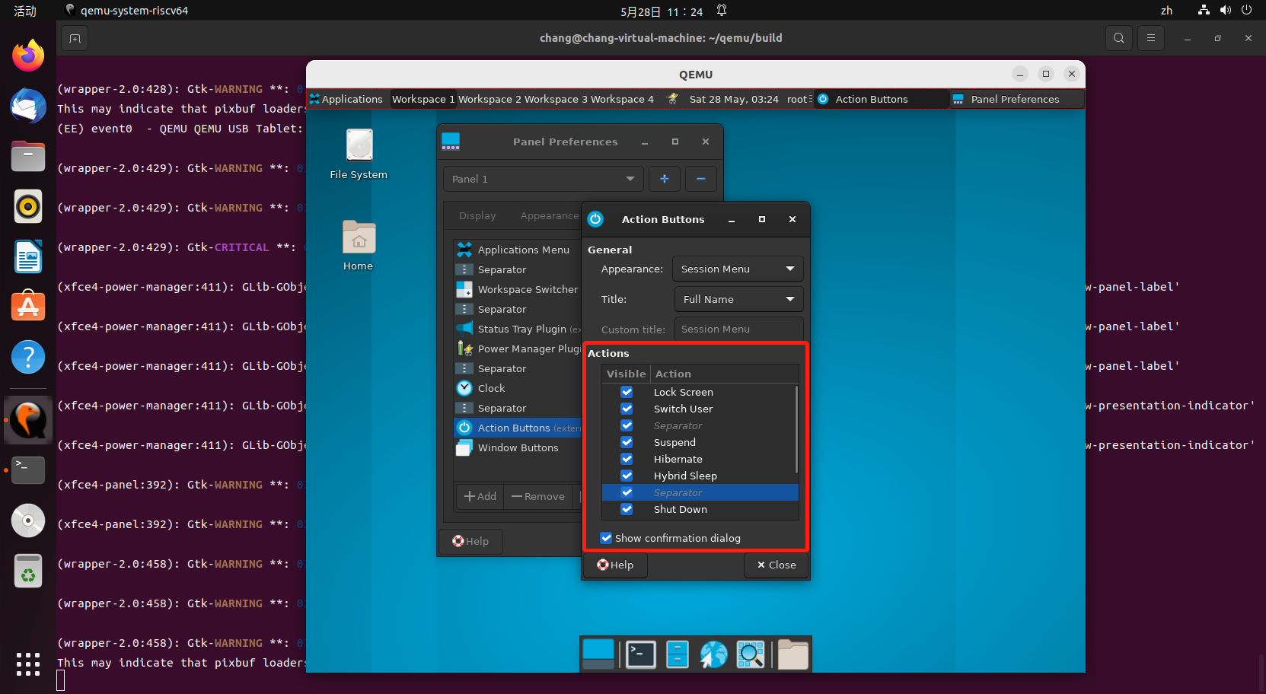

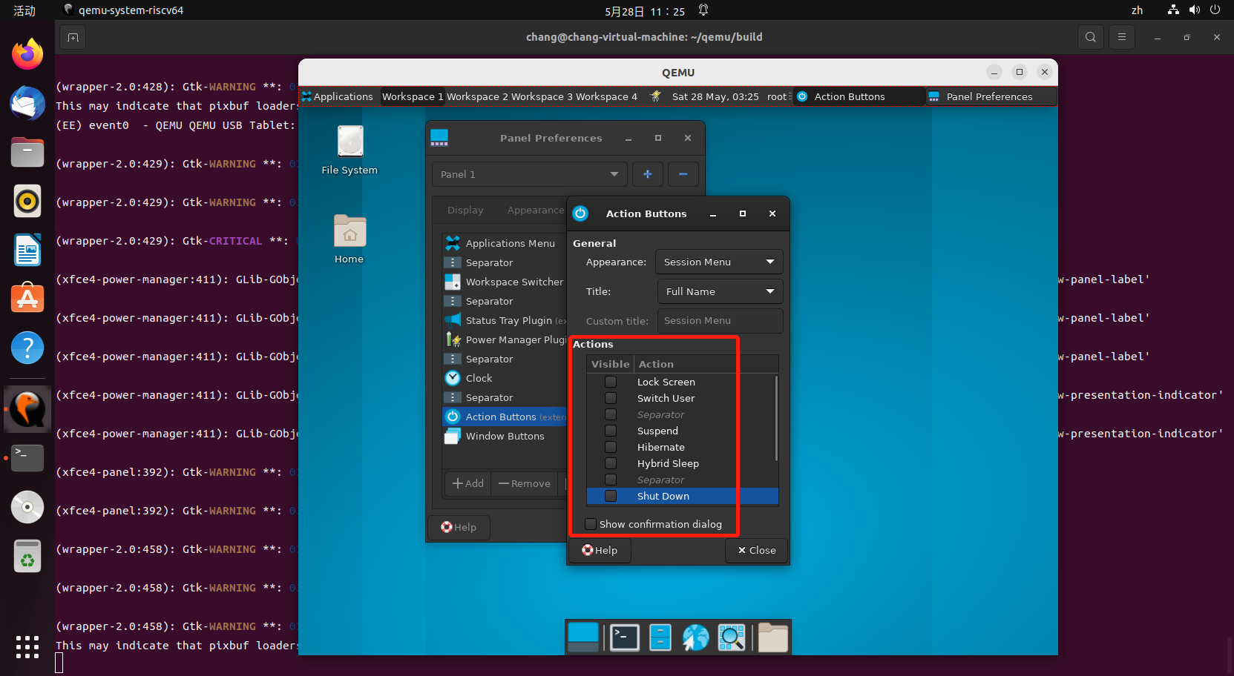

* Panel Appearance-Items-Windows Button测试

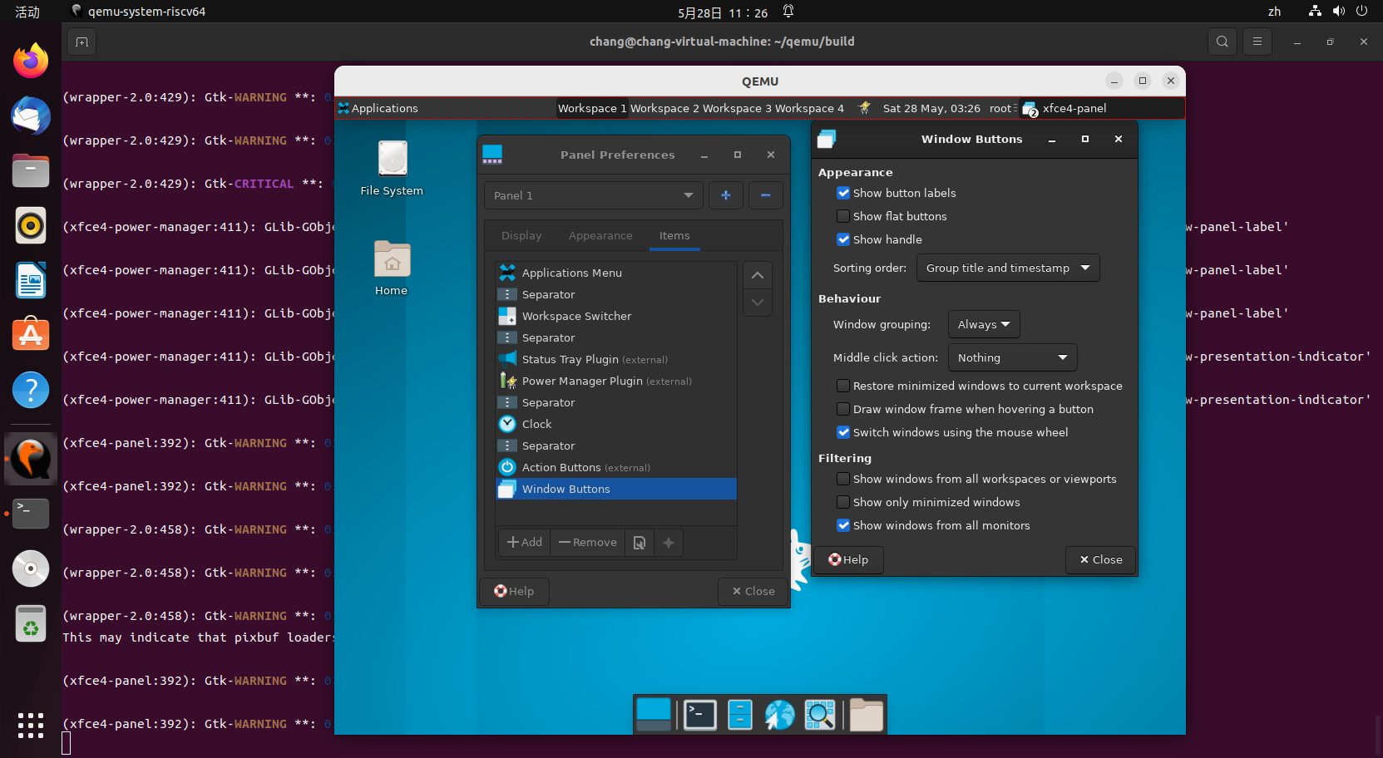

* Panel Appearance-Items-Windows Button下按钮勾选正常

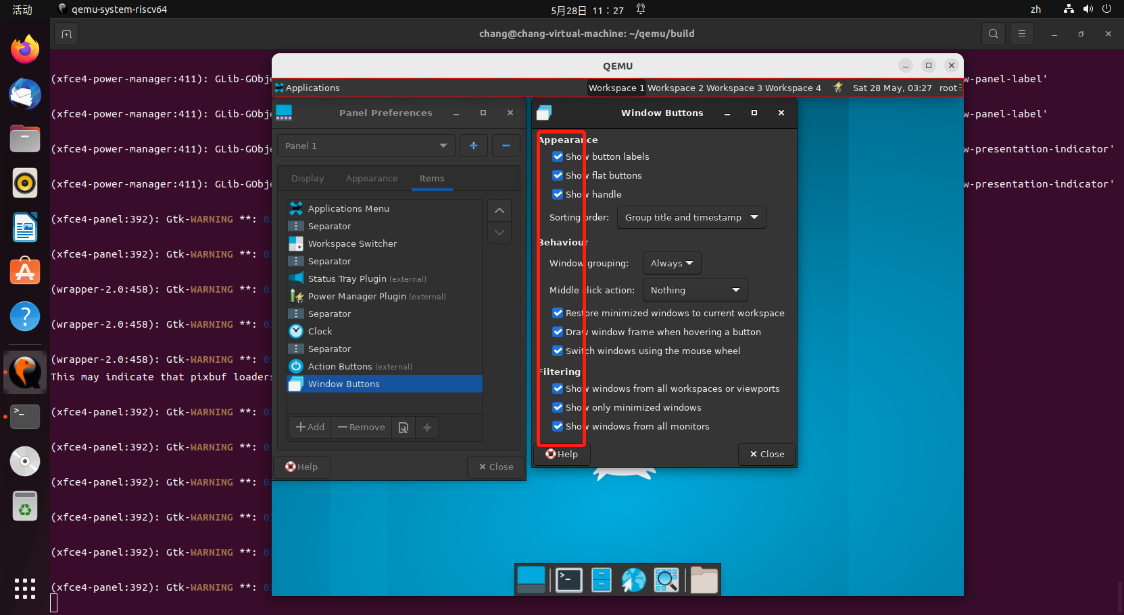

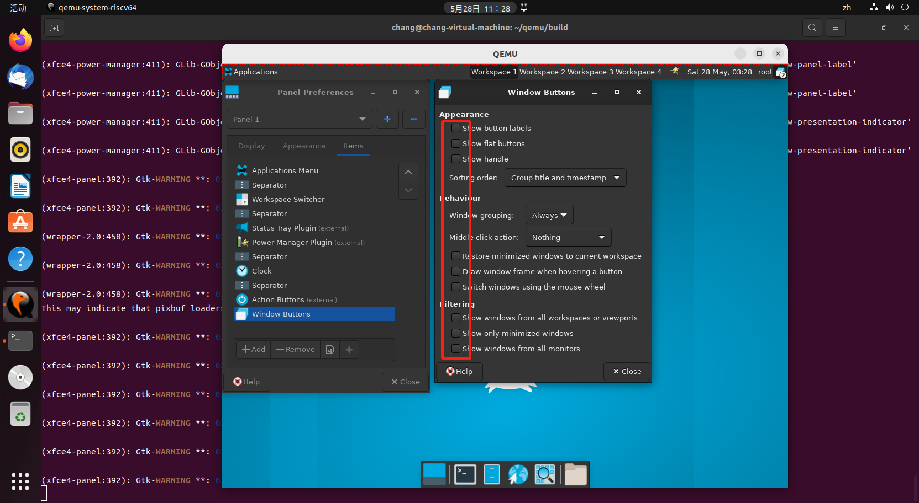

* Panel Appearance-Items-Windows Button下选择框功能正常

